
SepsisGuard: An AI and IoT-Driven Early Sepsis Warning Wearable System for Rural Hospitals
FINAL YEAR
PROJECT REPORT
Submitted by
ANAAS RAWOOF S (23619102)
ARVIN M (23619104)
VISHAL D (23619146)
in partial fulfilment for the award of the degree of
BACHELOR OF TECHNOLOGY CSE -
ARTIFICIAL INTELLIGENCE AND MACHINE LEARNING

DEPARTMENT OF ARTIFICIAL INTELLIGENCE AND MACHINE LEARNING
SCHOOL OF ENGINEERING
VELS INSTITUTE OF SCIENCE, TECHNOLOGY AND ADVANCED STUDIES (VISTAS)
CHENNAI
OCTOBER 2026

BONAFIDE CERTIFICATE
Certified that this project “SepsisGuard: An AI and IoT-Driven Early Sepsis Warning Wearable System for Rural Hospitals” is the bonafide work of ANAAS RAWOOF S (23619102), ARVIN M (23619104), VISHAL D (23619146) who carried out the project work under my supervision. Certified further that, to the best of my knowledge, the work reported here does not form part of any other project report or dissertation on the basis of which a degree or award was conferred on an earlier occasion on this or any other candidate.

SIGNATURE OF THE HOD  Dr. K. Ulaga Priya, M.E., Ph.D.  Associate Professor & Head  Department of AI & ML  School of Engineering  VISTAS  Chennai - 600 117 | SIGNATURE OF THE SUPERVISOR  Dr. Manikandan. A, M.E., Ph.D.  Assistant Professor  Department of AI & ML  School of Engineering  VISTAS  Chennai - 600 117

Submitted for the Project Work and Viva-Voce examination held on ……………… at Vels Institute of Science, Technology and Advanced Studies (VISTAS), Chennai – 600 117.

INTERNAL EXAMINER EXTERNAL EXAMINER
ACKNOWLEDGEMENT
It is certainly a great delight and proud privilege to acknowledge the help and support we received from the positive minds around us in making this venture a successful one. The infrastructural support with all kinds of lab facilities has been a motivating factor in the completion of this project work, all because of our FOUNDER & CHAIRMAN, Shri. Dr. ISHARI K. GANESH, and it is with great pleasure that we take this opportunity to thank him. We are grateful to our HEAD OF THE DEPARTMENT, Dr. K. Ulaga Priya, for her continuous support for the project, from initial advice and contacts in the early stages of conceptual inception, and through on-going advice and encouragement to this day. We extend our warmest thanks to our INTERNAL GUIDE, Dr. Manikandan. A, Assistant Professor, Department of AI & ML, who has patiently guided and provided us with invaluable advice and help. We would like to express our greatest gratitude to our staff members, Librarian, and non-teaching staff members of the Computer Centre, who have helped and supported us throughout. Last but not least, we wish to thank our parents and friends for their individual support and interest, who inspired and encouraged us to go our own way, without whom we would be unable to complete this project.

ANAAS RAWOOF S 23619102
ARVIN M 23619104
VISHAL D 23619146
TABLE OF CONTENTS
ABSTRACT 6
LIST OF FIGURES 7
LIST OF TABLES 8
LIST OF ABBREVIATIONS 9
1. INTRODUCTION 10
1.1 General 10
1.2 Problem Description 12
1.3 Existing System 13
1.4 Proposed System 13
1.5 Objectives 14
1.6 Scope of the Project 14
1.7 Contributions 15
1.8 Modules 15
1.9 Summary 16
2. LITERATURE REVIEW 17
2.1 Sepsis Definition and Early Recognition 17
2.2 Early Warning Scores 17
2.3 Machine-Learning Sepsis Prediction 18
2.4 Wearable and Optical Sensing 18
2.5 Embedded Platforms and Wireless Links 19
2.6 Alarm Fatigue 19
2.7 Existing Systems and Limitations 19
2.8 Research Gap 20
2.9 Human Factors and Browser-Based Monitoring 20
2.10 Standards and Regulatory Context 21
2.11 Summary 21
3. SYSTEM DESIGN 22
3.1 Existing System 22
3.2 Proposed System 22
3.3 System Architecture 22
3.4 Overall Workflow 23
3.5 Hardware Design 25
3.6 Early-Warning Logic 28
3.7 Watch Interface 29
3.8 Mobile Gateway Application (Phase 2 – Future Build) 30
3.9 Backend and Database Design 31
3.10 Dashboard Design 32
3.11 Data Flow 32
3.12 Hardware Requirements 33
3.13 Software Requirements 33
3.14 Design Decisions and Rationale 34
3.15 Safety, Privacy and Reliability Considerations 34
3.16 Power Considerations 35
3.17 Summary 35
4. IMPLEMENTATION AND METHODOLOGY 36
4.1 Development Environment and Approach 36
4.2 Firmware Structure 36
4.3 Sensor Acquisition and Conversion 37
4.4 Early-Warning Decision and Actuation 38
4.5 Display and Button Handling 38
4.6 Telemetry Protocol 39
4.7 Dashboard Implementation 39
4.8 Mobile Gateway (Phase 2 – Future Build) 41
4.9 Source Organisation and Reproducibility 41
4.10 Error Handling and Robustness 42
4.11 Development Challenges and Solutions 42
4.12 Summary 43
5. RESULTS AND DISCUSSION 44
5.1 Experimental Setup 44
5.2 Verification of the Early-Warning Rule 44
5.3 Functional Testing 46
5.4 Sensor Accuracy 47
5.5 Alert Latency 47
5.6 Dashboard Behaviour 48
5.7 Mobile Gateway Checks (Phase 2 – Future Build) 48
5.8 Power Considerations 49
5.9 Cost 49
5.10 Overall Discussion 50
5.11 Comparison with Existing Work 50
5.12 Failure Mode Analysis 51
5.13 Threats to Validity 51
5.14 Summary 52
6. DASHBOARD DEMONSTRATION AND MOBILE GATEWAY PLAN 53
6.1 Overview 53
6.2 The Ward Dashboard 53
6.3 Demonstration Scenarios 57
6.4 The Mobile Gateway (Phase 2 – Future Build) 59
6.5 How to Run the System 59
6.6 Troubleshooting Guide 59
6.7 Summary 60
7. CONCLUSION AND FUTURE WORK 61
7.1 Conclusion 61
7.2 Limitations 61
7.3 Future Scope 62
7.4 Summary 62
8. REFERENCES 63
9. APPENDIX 65
9.1 Pin and Address Quick Reference 65
9.2 Project Directory Structure 65
9.3 Main Commands 65
9.4 Bench Test Record Sheet 65
9.5 Glossary of Terms 66
9.6 Safety and Ethics Statement 66
10. SOURCE CODE 67
10.1 Overview of the Source Code 67
10.2 Static Web Server (server.js) 67
10.3 Telemetry Parser (js/parser.js) 68
10.5 State Store and Alert Ledger (js/state.js) 69
10.8 Application Controller and Alert Tone (js/app.js) 70

ABSTRACT
Sepsis is life-threatening organ dysfunction caused by a dysregulated response to infection, and early recognition of a deteriorating patient shortens the time to assessment and treatment. In many general wards, however, vital signs are recorded on paper at scheduled rounds, nothing is measured in between, and fixed bedside monitors are too costly to place at every bed. This report presents SepsisGuard, a low-cost wearable early-warning prototype that measures continuously, decides on the device and streams the same data to a ward dashboard. The watch is built around a Seeed Studio XIAO ESP32-C3 microcontroller that reads a TMP117 digital temperature sensor, a MAX30102 optical pulse sensor and an MPU6050 motion sensor over one I2C bus. The firmware converts the raw values to degrees Celsius, beats per minute and tilt angle, evaluates the warning rule (T > 34.0 °C or |θ| > 90.0°, strict comparisons, demonstration setpoints), and on a breach drives a buzzer on GPIO8 and shows a warning on an SSD1306 OLED. A push button cycles the display through temperature, heart rate, orientation and sensor diagnostics. Because the decision is made on the watch, the local alarm does not depend on a network, a server or a browser.
Each reading cycle is also printed as text. In the prototype the text is read over USB serial by a zero-backend browser dashboard that uses the Web Serial API; the mobile gateway application is a future build planned for Phase 2 and is described here as a design only, in which the same text will travel over Bluetooth Low Energy to an Android gateway that binds the watch to a patient, buffers data offline and forwards it to a hospital server. The dashboard offers live cards, trend charts, a red alert banner with a synthesised tone, an alert ledger with acknowledgement, adjustable limits, reports and export. A transport-independent text protocol lets each part be built and tested separately. A missing heart-rate sensor is shown as disconnected and never as an invented number. The project states its limits plainly: the limits are demonstration setpoints and not a clinical fever threshold, the sensors are not clinical-grade, and the system has not been tested on patients. SepsisGuard is a decision-support prototype that demonstrates a workable and inexpensive architecture for bedside early warning, not a diagnostic device.
Keywords — sepsis, early warning, wearable, ESP32-C3, TMP117, MAX30102, MPU6050, Web Serial, Bluetooth Low Energy, rural healthcare

LIST OF FIGURES
Figure No. | Title | Page.No
Figure 1.1 | Four-tier architecture of SepsisGuard | 11
Figure 1.2 | Observation gaps between scheduled rounds and continuous measurement (illustrative data) | 13
Figure 3.1 | Current prototype versus planned production architecture | 23
Figure 3.2 | End-to-end data flow between patient, watch, gateway, backend and dashboard | 24
Figure 3.3 | Hardware connection diagram of the wearable node | 26
Figure 3.4 | Photograph of the assembled SepsisGuard prototype | 26
Figure 3.5 | Four devices share one I2C bus | 27
Figure 3.6 | Early-warning decision logic | 28
Figure 3.7 | Alert propagation from the patient to the dashboard | 29
Figure 3.8 | The four OLED screens of the watch (illustrative rendering) | 29
Figure 3.9 | Photographs of the OLED showing the temperature, heart-rate, orientation and diagnostics screens | 30
Figure 3.10 | Planned data flow through the mobile gateway (Phase 2) | 31
Figure 3.11 | Planned database model (entity-relationship) | 32
Figure 3.12 | Views of the hospital dashboard | 32
Figure 4.1 | Flowchart of the firmware main loop | 37
Figure 4.2 | Dashboard JavaScript modules and their connections | 39
Figure 5.1 | Photograph of the experimental setup | 44
Figure 5.2 | Decision regions of the early-warning rule | 45
Figure 5.3 | Screenshot or photograph used for the latency measurement | 48
Figure 6.1 | Overview view of the dashboard in the normal state (illustrative rendering) | 54
Figure 6.2 | Screenshot of the Overview view of the real dashboard | 54
Figure 6.3 | Alerts view with an active warning banner and the alert ledger | 55
Figure 6.4 | Screenshot of the Alerts view of the real dashboard with an active alert | 56
Figure 6.5 | Trends view with temperature and tilt history (illustrative rendering) | 56
Figure 6.6 | Settings view with adjustable limits (illustrative rendering) | 57
Figure 6.7 | Screenshot of the Reports view and an exported file | 57

LIST OF TABLES
Table No. | Title
Table 1.1 | Project Objectives
Table 2.1 | Comparison of SepsisGuard with Existing Approaches
Table 3.1 | Major System Modules
Table 3.2 | Pin Assignment of the Wearable Node
Table 3.3 | I2C Address Map
Table 3.4 | Sensors and Their Role in Early Warning
Table 3.5 | Hardware Requirements and Bill of Materials
Table 3.6 | Software Requirements
Table 3.7 | Principal Design Decisions
Table 4.1 | Fields of a Telemetry Cycle
Table 4.2 | Development Challenges and Solutions
Table 5.1 | Boundary Values of the Early-Warning Rule
Table 5.2 | Functional Testing Summary
Table 5.3 | Temperature Comparison with a Reference Thermometer
Table 5.4 | Alert Latency Measurements
Table 5.5 | Planned Mobile Gateway Checks (Phase 2)
Table 5.6 | Cost Comparison
Table 5.7 | Comparison of SepsisGuard with Existing Approaches
Table 5.8 | Failure Mode Analysis
Table 6.1 | Dashboard Views
Table 6.2 | Demonstration Scenarios and Expected Behaviour
Table 6.3 | Troubleshooting Guide
Table 9.1 | Pin and I2C Quick Reference
Table 9.2 | Bench Test Record Sheet (template)
Table 9.3 | Glossary

LIST OF ABBREVIATIONS
Abbreviation | Full Form
AI | Artificial Intelligence
ML | Machine Learning
IoT | Internet of Things
BLE | Bluetooth Low Energy
GATT | Generic Attribute Profile
I2C | Inter-Integrated Circuit
SDA / SCL | Serial Data / Serial Clock
GPIO | General-Purpose Input/Output
PPG | Photoplethysmography
NEWS2 | National Early Warning Score 2
qSOFA | Quick Sequential Organ Failure Assessment
SOFA | Sequential Organ Failure Assessment
OLED | Organic Light-Emitting Diode
LiPo | Lithium Polymer
RSSI | Received Signal Strength Indicator
REST | Representational State Transfer
MRN | Medical Record Number
EHR | Electronic Health Record
PHC | Primary Health Centre
USB | Universal Serial Bus
CHAPTER 1

INTRODUCTION

1.1 General
Sepsis is life-threatening organ dysfunction caused by a dysregulated host response to infection [1]. It can progress from a local infection, such as pneumonia or a urinary tract infection, to circulatory failure, septic shock and death within hours. Rudd et al. estimated 48.9 million incident cases and 11.0 million sepsis-related deaths worldwide in 2017, about one in five of all deaths that year, with a large share in low- and middle-income regions [2]. Sepsis is therefore a problem of timing as much as of treatment: the sooner a deteriorating patient is recognised, the sooner assessment and antimicrobial therapy can begin [3], [14].
In a general ward the first signs of sepsis are easy to miss. Temperature drifts, the pulse quickens, the patient becomes restless or lies in an unusual posture, and none of these changes is specific to infection. In many rural and district hospitals the nurse who could notice them is responsible for many beds, and vital signs are written on a paper chart at scheduled rounds. Between rounds nothing is measured and nobody is alerted. A fixed bedside monitor would close that gap, but it costs far more than a small facility can place at every bed, and it ties the patient to the wall.
Two things are therefore missing in such wards: continuous measurement that follows the patient, and a warning that does not depend on someone happening to look at the right chart at the right time. Both are within reach of present low-cost electronics. A wrist-worn module can carry a digital temperature sensor, an optical pulse sensor and a motion sensor, a microcontroller with built-in Bluetooth Low Energy can read them and take a simple decision on the spot, and a browser can display the stream for the nurse without installing any special software.
This project, SepsisGuard, builds such a system. It is a wearable early-warning node together with a ward dashboard; a mobile gateway is planned as a future build in Phase 2. The decision to warn is taken on the watch itself, so the bedside alarm still works if the network, the server or the browser fails. The same readings are sent to a central dashboard where staff see live values, trends and alerts and can acknowledge each alert. SepsisGuard is a decision-support prototype. It does not diagnose sepsis and it does not replace clinical judgement, laboratory tests or a validated early-warning score.
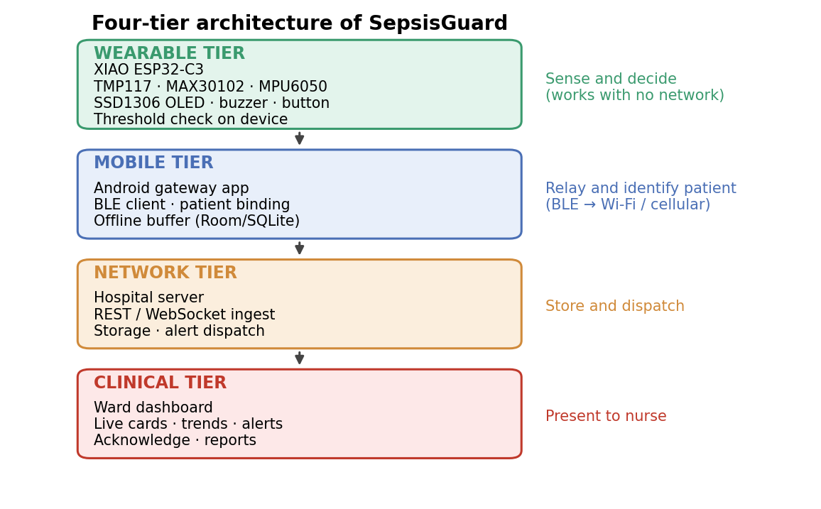
Figure 1.1: Four-tier architecture of SepsisGuard

1.1.1 Why Early Recognition Matters
Sepsis does not announce itself with one dramatic sign. The body’s response to infection changes temperature, pulse, breathing, blood pressure and alertness together, and each change has many other causes. What distinguishes a patient who is heading towards sepsis is usually a trend: a measurement that keeps moving in the wrong direction over hours. A system that records a value only every few hours can show a single abnormal point, but it cannot show the trend, and it cannot show that the trend has begun.
The clinical literature links delay to harm. Studies of septic shock and of sepsis care bundles associate longer delays before effective treatment with worse survival [5], [14], and the Surviving Sepsis Campaign recommends rapid assessment and prompt antimicrobial therapy when sepsis is likely [3]. These findings do not define a fixed time window that applies to every patient, and this report does not claim one. They do give a clear engineering target: shorten the time between the start of deterioration and the moment someone looks at the patient.

1.1.2 Signals a Wearable Can Capture
A low-cost wrist-worn node can capture three kinds of signal. Skin or body temperature shows fever or an abnormally low temperature, both of which can accompany severe infection, although some patients with sepsis have no fever. A pulse signal from an optical sensor gives heart rate, and a persistently raised heart rate is a common early response to infection, pain or dehydration. A motion sensor gives the orientation of the forearm and the amount of movement, which can reveal a fall, a patient who has not moved for a long time or an unusual posture.
None of these signals is specific to sepsis, and none of them alone can diagnose it. Their value is as continuous, inexpensive indicators that something has changed and that a nurse should look. This is why SepsisGuard is described throughout as an early-warning prototype and why its limits are called demonstration setpoints. A clinical score such as NEWS2 [7] also needs respiratory rate, blood pressure, oxygen saturation and level of consciousness, which the prototype does not measure.

1.1.3 The Setting: Wards with Limited Monitoring
The design is aimed at general wards in district and rural hospitals, where a nurse may be responsible for many patients, where fixed monitors are scarce, where power and network connections may be unreliable and where equipment must be cheap and easy to repair. These conditions explain several design choices: the decision is taken on the watch so that it survives network failure, the node is built from common breakout boards, the dashboard needs no server, and every alert is recorded so that the ward can review what happened.

1.2 Problem Description
The problem addressed by this project is how to watch a ward patient continuously at low cost and raise a clear, immediate warning when the measurements move outside agreed limits, without depending on a network connection, a cloud service or a bedside monitor at every bed. The solution should be small enough to wear, should show its reading locally, should stream the same data to staff, and should keep an auditable record of every alert.
Several practical difficulties make the problem harder than it first appears. First, the observation gap between scheduled rounds is invisible: the chart gives no indication of which hours were unobserved, so a deterioration that begins just after a round can go unnoticed for hours (Figure 1.2). Second, a warning that only travels over a network is unreliable in the settings where it is most needed, because Wi-Fi coverage, power and servers fail. Third, alarms that fire too often are ignored; alarm fatigue is a recognised patient-safety concern [15], so the system must make alert conditions explicit, adjustable and acknowledgeable. Fourth, the hardware has to be cheap, have a small number of parts and be easy to assemble from common breakout boards. Finally, a student prototype must be honest about what it can claim: its sensors are not clinical-grade, its limits are demonstration setpoints, and it has not been validated on patients.
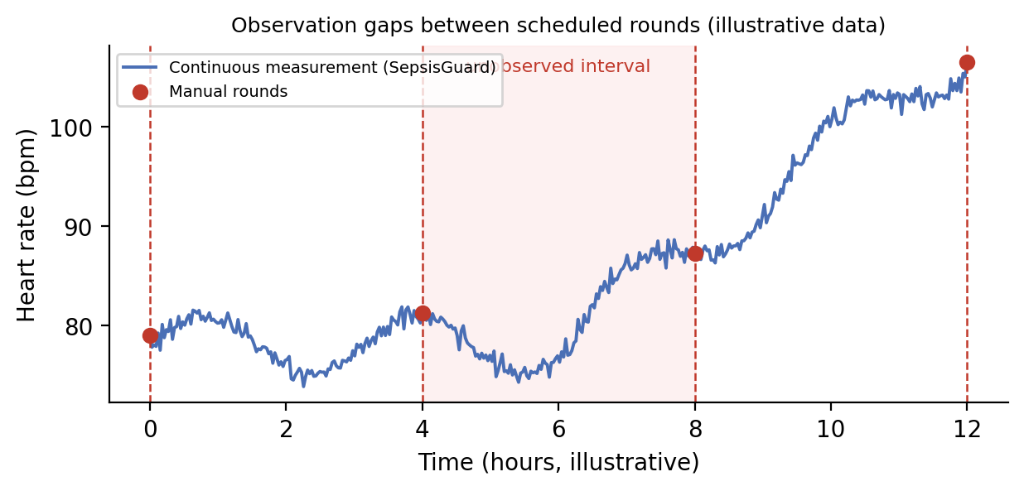
Figure 1.2: Observation gaps between scheduled rounds and continuous measurement (illustrative data)

1.3 Existing System
In the existing workflow of a general ward, a patient is observed by a nurse at scheduled rounds. Measurements are written on a chart, and any early warning score is computed by hand or on a workstation. Where a hospital uses a structured score such as NEWS2, the score combines respiratory rate, oxygen saturation, blood pressure, pulse, consciousness and temperature into one number that triggers a response [7]. Such scores are valuable, but they are only as frequent as the observations that feed them.
Fixed multi-parameter monitors measure continuously and sound alarms, but they are expensive, need mains power and wall mounting, and are usually reserved for intensive-care and high-dependency beds. Research systems that apply machine learning to electronic health records predict sepsis or deterioration well [6], [8], [9], [12], but they depend on laboratory values, charted vital signs and a hospital information system that a small rural facility may not have. They also run on servers rather than at the bedside.
Existing approaches therefore leave a gap for a wearable, battery-powered, inexpensive node that measures continuously and decides locally. Section 2.7 compares these approaches in more detail.

1.4 Proposed System
SepsisGuard moves the safety decision to the patient. A Seeed Studio XIAO ESP32-C3 microcontroller reads a TMP117 digital temperature sensor, a MAX30102 optical pulse sensor and an MPU6050 motion sensor over one I2C bus. The firmware converts the raw values into degrees Celsius, beats per minute and tilt angles, compares them with the safety limits, and on a breach drives a buzzer and shows a warning on a 128 × 64 OLED display. A push button cycles the display through temperature, heart rate, orientation and sensor diagnostics.
The watch also prints every reading cycle as a line of text. In the working prototype this text travels over USB serial and is read directly by the dashboard in the browser using the Web Serial API. In Phase 2 (a future build) the same text protocol will be carried over Bluetooth Low Energy to an Android gateway application, which will attach the patient identity, buffer data while the network is down and forward it to a hospital server. The ward dashboard shows live patient cards, trend charts, alert banners with an audible tone, an alert ledger with acknowledgement, and exportable reports.
Because the dashboard speaks only to the text protocol, the transport can be changed from a cable to Bluetooth without changing the dashboard logic. This is the central design decision of the project and is explained in Chapter 3.

1.5 Objectives
The objectives of the project are summarised in Table 1.1.
Table 1.1: Project Objectives
No. | Objective
1 | Build a wearable node that measures temperature, heart-rate signal and orientation continuously from low-cost digital sensors on a single I2C bus.
2 | Evaluate early-warning limits on the device itself and drive a local buzzer and OLED warning without any network dependency.
3 | Provide a four-screen watch interface for temperature, heart rate, orientation and sensor diagnostics, operated by one push button.
4 | Define a simple text protocol so the same data can travel over USB serial now and Bluetooth Low Energy later.
5 | Build a browser-based ward dashboard with live cards, trend charts, alert banner with tone, alert acknowledgement, settings, reports and exports.
6 | Design an Android gateway application that will relay the watch stream, bind it to a patient record and buffer data offline; its development is planned as a future build in Phase 2.
7 | Document the hardware, firmware, software and testing in a reproducible way, and state clearly the limits of what the prototype can claim.

1.6 Scope of the Project
The project covers one wearable node built around the XIAO ESP32-C3 Mini, and one dashboard written in HTML, CSS and JavaScript. An Android gateway application that relays the watch stream is a future build planned for Phase 2 and is described in this report as a design only. The measured quantities are body or skin temperature, a pulse signal and the orientation of the forearm. The early-warning rule uses fixed, adjustable setpoints.
The project does not claim to diagnose sepsis. The temperature limit of 34.0 °C is a demonstration setpoint for laboratory prototyping and skin-surface measurement, not a clinical fever threshold. The project does not include blood pressure, respiratory rate or laboratory values, does not train a machine-learning model, has not been tested on patients, and is not a certified medical device. It provides a warning that can help decide when a nurse should assess a patient, nothing more.

1.7 Contributions
- A complete low-cost wearable early-warning node with local decision, local alarm and local display that continues to work when every other part of the system is offline.
- A simple, human-readable text protocol that decouples the embedded firmware from the dashboard and from the transport, so that USB serial (used in the prototype) and Bluetooth Low Energy (planned for Phase 2) are interchangeable.
- A zero-backend ward dashboard that reads the watch directly in the browser, with live cards, charts, alert ledger, acknowledgement, adjustable limits, reports and export.
- A design for an Android gateway, planned as a future build in Phase 2, with patient binding, a foreground service, an offline buffer and acknowledgement by named staff.
- A clear statement of the early-warning rule, its strict comparison semantics and its demonstration-only status, together with a verification of the rule across its boundary values.
- A documented hardware design with pin assignment, I2C address map and bill of materials that others can reproduce.

1.8 Modules
The system is organised into five modules. They are listed with their responsibilities in Table 3.1 in Chapter 3 and implemented in Chapter 4, except the gateway module, which is a future build planned for Phase 2.
- Sensing module: the TMP117, MAX30102 and MPU6050 and their drivers on the shared I2C bus.
- Decision and actuation module: threshold evaluation, buzzer output, OLED screens and button handling in the firmware.
- Protocol module: formatting of each reading cycle as text on the watch and parsing of cycles on the host.
- Gateway module (Phase 2, future build): the Android application that will relay, identify, buffer and forward the stream.
- Dashboard module: serial manager, parser, state store, charts, reports and the user-interface controller.

1.9 Summary
This chapter explained why early recognition of deterioration matters, described how monitoring in a general ward leaves unobserved gaps, and introduced SepsisGuard, a wearable early-warning node with a local alarm and a ward dashboard, with a mobile gateway planned as a future build in Phase 2. It also set out the objectives, scope, contributions and modules of the project. The next chapter reviews the literature on which the project builds.
CHAPTER 2

LITERATURE REVIEW

2.1 Sepsis Definition and Early Recognition
Singer et al. [1] presented the Third International Consensus Definitions for Sepsis and Septic Shock (Sepsis-3), which define sepsis as life-threatening organ dysfunction caused by a dysregulated host response to infection. The definition separates sepsis from uncomplicated infection by the presence of organ dysfunction, measured clinically by a change in the Sequential Organ Failure Assessment (SOFA) score. Because SOFA needs laboratory values, the task force also proposed a bedside prompt, quick SOFA (qSOFA), based on altered mentation, a raised respiratory rate and a low systolic blood pressure.
Seymour et al. [4] assessed these clinical criteria in a large retrospective cohort and found that qSOFA was useful for identifying patients outside intensive care who were at risk of poor outcome. Their work shows that simple bedside measurements, taken early and repeatedly, carry real prognostic information. It also shows the limit of a single bedside prompt: every criterion depends on someone measuring it at the right time.
The importance of time has been shown repeatedly. Kumar et al. [5] reported that survival in septic shock fell with each hour of delay before effective antimicrobial therapy, and Seymour et al. [14] found that a longer time to completion of a sepsis care bundle was associated with higher in-hospital mortality. Evans et al. [3], in the Surviving Sepsis Campaign guidelines, recommend rapid assessment and prompt antimicrobial treatment for adults with possible septic shock or a high likelihood of sepsis. These results justify systems that shorten the time to recognition, although none of them establishes a universal fixed time window.

2.2 Early Warning Scores
Aggregate early-warning scores convert routine observations into a single number that triggers a graded clinical response. The National Early Warning Score 2 (NEWS2) of the Royal College of Physicians [7] scores respiratory rate, oxygen saturation, use of supplemental oxygen, systolic blood pressure, pulse, level of consciousness and temperature. Each parameter has a band, the bands add up, and the total decides how urgently the patient is reviewed. NEWS2 is simple, transparent and widely used, and its transparency is its strength: a nurse can see which parameter raised the score.
Churpek et al. [8] compared machine-learning methods with conventional regression for predicting clinical deterioration on hospital wards and found that tree-based and other machine-learning models predicted deterioration more accurately than logistic regression on vital-sign data. The study supports the use of richer models, but it also shows the typical setting of such work: retrospective data from a hospital with a full electronic record. Whether a simple rule or a learned model is used, the score is only as frequent as the observations behind it.

2.3 Machine-Learning Sepsis Prediction
Several systems predict sepsis from electronic health records. Desautels et al. [6] developed InSight, a model that uses a small set of vital signs and demographic data from the MIMIC database [10] to detect and predict sepsis. Henry et al. [9] developed TREWScore, which estimates the risk of septic shock hours before onset from vital signs and laboratory values. The PhysioNet/Computing in Cardiology Challenge 2019 [12] invited many teams to predict sepsis early using a utility-based score that rewards early correct alerts and penalises late and false ones.
These studies show that sepsis can be anticipated from routine data, but three limitations matter for a small rural ward. The models depend on laboratory results and charted vital signs that may not exist. They run on hospital servers and give no warning at the bedside. And they are validated on data from large hospitals that differ from the population of a district hospital. They are therefore complementary to a bedside wearable and not a substitute for one.

2.4 Wearable and Optical Sensing
Allen [13] reviewed photoplethysmography (PPG), the optical technique used by pulse oximeters and wearable heart-rate sensors. Light from red and infrared LEDs passes through or reflects from tissue, and the changing absorption with each pulse of arterial blood gives a waveform from which heart rate can be derived. The same review stresses that PPG is sensitive to motion, contact pressure, skin perfusion and ambient light, so a reading without an indication of signal quality can mislead.
SepsisGuard follows this guidance in its design. The MAX30102 [17] is read as a heart-rate sensor, and the dashboard marks heart rate as disconnected when no valid signal is present instead of showing a false value. The temperature sensor, the TMP117 [16], is a digital device with a typical accuracy of ±0.1 °C and a resolution of 0.0078125 °C, which makes it suitable for trend monitoring. The MPU6050 [18] adds acceleration and angular rate, from which the tilt of the forearm is computed.

2.5 Embedded Platforms and Wireless Links
The Espressif ESP32-C3 [20] is a 32-bit RISC-V microcontroller with Wi-Fi and Bluetooth 5 (LE) in a small package. The Seeed Studio XIAO ESP32-C3 [21] places it on a board small enough for a wrist-worn node with a lithium-polymer battery charger. Bluetooth Low Energy exposes data through the Generic Attribute Profile (GATT), in which a peripheral publishes values as characteristics and a central device subscribes to notifications [23]. This model fits a watch that sends small records to a nearby phone.
Sensors and displays on the node share the I2C bus [19], in which each device answers to its own 7-bit address. This lets four peripherals use two wires and no multiplexer. On the host side, the Web Serial API [24] allows a web page in a Chromium-based browser to read a serial device after the user grants permission, and the Web Audio API [25] allows the page to synthesise an alert tone. Together they make it possible to build a dashboard that needs no server, driver or installed software.

2.6 Alarm Fatigue
Sendelbach and Funk [15] reviewed alarm fatigue, the desensitisation of staff exposed to a high number of alarms, many of which are false or non-actionable. They describe it as a patient-safety concern and recommend adjusting alarm parameters, individualising limits and reducing unnecessary alarms. This is a direct design constraint on any early-warning system. SepsisGuard keeps its rule short and explicit, uses strict comparisons so that a reading on the limit is not an alert, lets staff adjust limits in the dashboard settings, requires a nurse to acknowledge an alert, and records every alert with its time in a ledger.

2.7 Existing Systems and Limitations
Table 2.1 compares the main families of existing approaches with the proposed system. The comparison is based on what each approach needs in order to produce a warning, because the approaches differ in data, setting and purpose and no head-to-head accuracy experiment was run in this project.

Table 2.1: Comparison of SepsisGuard with Existing Approaches
Approach | Needs | Continuous | Local alarm | Typical cost
Manual rounds with paper chart | Nurse time | No | No | Low
NEWS2 on a workstation [7] | Charted vitals, staff entry | No | No | Low
Fixed bedside monitor | Mains power, wall mount | Yes | Yes | High per bed
EHR machine-learning models [6], [9], [12] | Hospital information system, laboratory data | Depends on charting | No | Server and integration
SepsisGuard (this work) | Wearable node, USB cable, browser (phone gateway planned for Phase 2) | Yes | Yes, on the watch | Low (see Section 5.9)

The limitations of the literature are therefore practical. Scores and models depend on charted observations or hospital records. Fixed monitors are expensive and stationary. Wearable research often reports sensing accuracy but not the full path from sensor to nurse. And few systems state plainly that their thresholds are for demonstration and not for clinical use.

2.8 Research Gap
Based on this review, the gap addressed by this project is the combination of four elements that are usually studied separately: continuous measurement from low-cost digital sensors, a safety decision taken on the device so that the local alarm survives network failure, a transport-independent text protocol that carries the same data over USB (implemented) and Bluetooth Low Energy (planned for Phase 2), and a browser dashboard with explicit, adjustable limits and an auditable alert ledger. The project also states its limits openly: demonstration setpoints, non-clinical sensors and no patient validation.

2.9 Human Factors and Browser-Based Monitoring
A monitoring interface is judged by what a tired nurse can read at a glance. The literature on alarm management stresses clear priorities, consistent colours and the ability to review what happened [15]. SepsisGuard follows this by reserving red for alerts, showing the connection state in a fixed header, using large cards for the live values and keeping an alert ledger with times. A browser interface has a further advantage in a resource-limited ward: it runs on any computer that has a supported browser, needs no installation, and can be changed by editing files, which lowers the cost of maintenance.
The Web Serial API [24] limits the prototype to Chromium-based browsers and requires the user to grant access to the port, which is also a safeguard because a page cannot open a device without the user’s action. The Web Audio API [25] produces the alert tone in the page without any audio file. Neither API needs a server, which is why the prototype can run from a folder on a workstation with no network at all.

2.10 Standards and Regulatory Context
Clinical monitoring equipment is regulated. Alarm systems of medical electrical equipment are covered by the IEC 60601 family of standards, and the management of risk in medical devices by ISO 14971, and a device used for diagnosis or monitoring of patients normally needs approval from the relevant regulator before clinical use. SepsisGuard is a student prototype that has not been designed, tested or certified to these standards. It is therefore presented only as a demonstration of an architecture and must not be used to make decisions about real patients. Any future clinical version would need a documented risk analysis, usability engineering, electrical safety and electromagnetic compatibility testing, and an ethics-approved clinical evaluation.

2.11 Summary
This chapter reviewed the definition and timing of sepsis, early-warning scores, machine-learning prediction, optical sensing, embedded and wireless platforms and alarm fatigue. Existing approaches depend on charted observations, hospital records or expensive stationary monitors, and rarely combine a local alarm with a transport-independent data path. These gaps define the research gap addressed by this project. The next chapter presents the system design.
CHAPTER 3

SYSTEM DESIGN

3.1 Existing System
In the existing workflow of a general ward, a patient is observed by a nurse at scheduled rounds. Measurements are written on a chart, and any early warning score is computed by hand or on a workstation. Between rounds nothing is measured, nobody is alerted automatically, and the chart gives no indication of which hours were unobserved. Where a fixed monitor is available, it measures continuously but ties the patient to the bedside and is too costly to place at every bed.

3.2 Proposed System
The proposed system moves the safety decision to the patient. The watch measures continuously, evaluates the thresholds on the device, and sounds a buzzer as soon as a limit is crossed. At the same time it sends every reading to a central dashboard, where the nurse sees live values, trends and alerts and can acknowledge each alert. Because the decision is made on the device, the local warning does not depend on a network, a server or a browser.
The system is split into an embedded part (the watch) and a host part (the dashboard), joined by a simple text protocol. This separation lets the host software be developed and tested without hardware, by feeding it recorded text from the watch, and lets the transport be changed from a USB cable to Bluetooth Low Energy without changing the dashboard logic.

3.3 System Architecture
Figure 1.1 in Chapter 1 shows the four tiers. The wearable tier senses and decides. The mobile tier, a future build planned for Phase 2, will relay the stream wirelessly and attach the patient identity. The network tier stores telemetry and dispatches alerts. The clinical tier presents the data to staff. In the working prototype, the mobile and network tiers are replaced by a direct USB serial connection, as compared in Figure 3.1. Table 3.1 lists the modules of the implementation and their responsibilities.
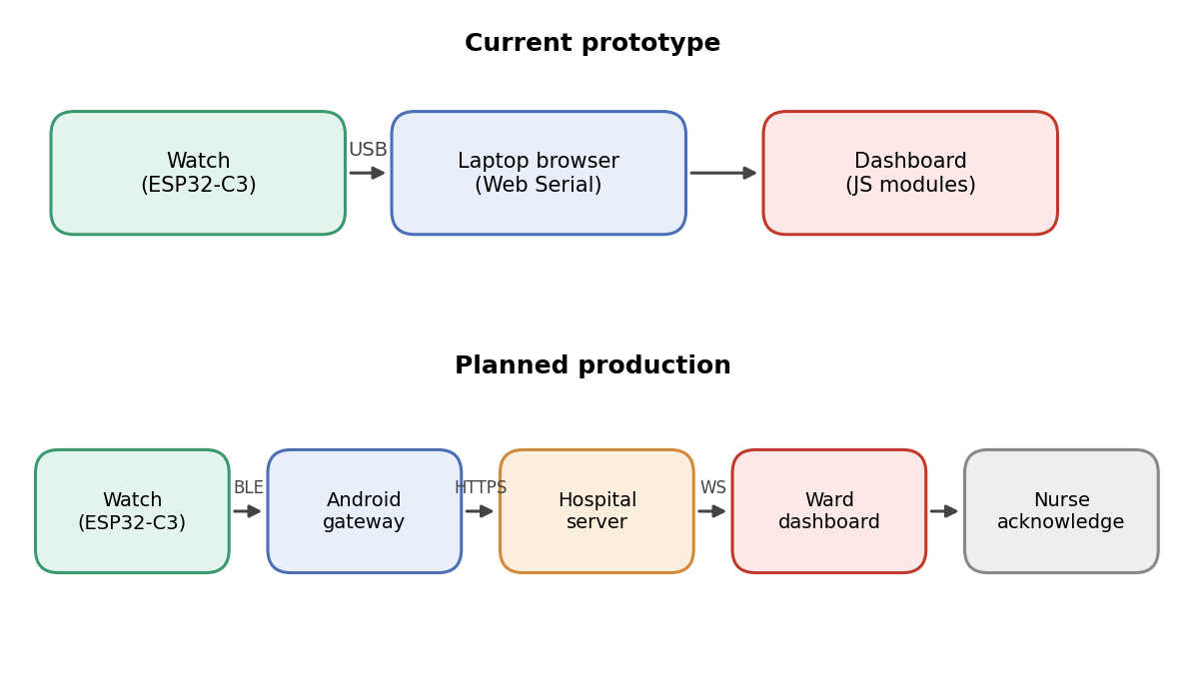
Figure 3.1: Current prototype versus planned production architecture
Table 3.1: Major System Modules
Module | Responsibility
Firmware: sensor drivers | Read TMP117, MAX30102 and MPU6050 over I2C and convert raw values to engineering units.
Firmware: decision logic | Evaluate the early-warning rule, drive the buzzer on GPIO8 and set the warning state.
Firmware: display and button | Draw the four OLED screens and change screen on a button press.
Firmware: protocol | Print one telemetry cycle as text over serial (prototype) or BLE (Phase 2).
Dashboard: serial manager | Open the serial port with Web Serial and deliver incoming lines.
Dashboard: parser | Assemble complete cycles from lines and validate them.
Dashboard: state store | Hold history, evaluate the alert condition, keep the alert ledger and notify the interface.
Dashboard: UI controller, charts, reports | Redraw cards, charts and banners; produce reports and exports; play the alert tone.
Android gateway (Phase 2, planned) | Planned: receive the BLE stream, bind it to a patient, buffer offline and forward to the server.

3.4 Overall Workflow
The complete flow from patient to alert consists of thirteen steps, shown in Figure 3.2.
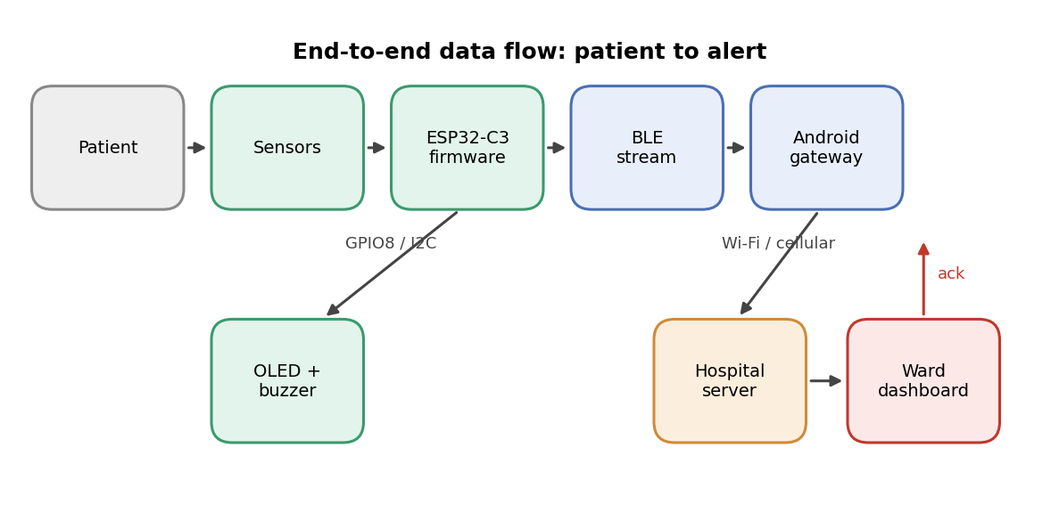
Figure 3.2: End-to-end data flow between patient, watch, gateway, backend and dashboard
- Sensor placement. The patient wears the watch. The TMP117 and MAX30102 keep contact with the skin and the MPU6050 moves with the forearm.
- Signal capture. The sensors continuously convert temperature, reflected light and acceleration into digital values.
- Register reading. The ESP32-C3 reads the sensors as an I2C controller on GPIO6 (SDA) and GPIO7 (SCL).
- Computation. Firmware converts raw values into degrees Celsius, beats per minute and tilt angles.
- Threshold evaluation. The firmware compares the readings with the safety limits.
- Edge actuation. On a breach, GPIO8 drives the buzzer and the OLED shows a warning.
- Dispatch. The firmware prints a telemetry cycle (serial in the prototype, Bluetooth Low Energy in Phase 2).
- Mobile ingestion (Phase 2). In the planned design the bedside Android gateway receives the stream.
- Gateway processing (Phase 2). The planned gateway attaches the patient identity and validates the packet.
- Forwarding (Phase 2). The planned gateway sends records to the hospital server over Wi-Fi or cellular data.
- Backend storage. The server validates and stores records and flags anomalies.
- Dashboard rendering. The ward dashboard updates patient cards, charts and status badges.
- Alarm and audit. An audible alarm sounds, an alert badge lights and a timestamped entry is written to the alert ledger.

3.5 Hardware Design

3.5.1 Microcontroller
The wearable is built around the Seeed Studio XIAO ESP32-C3 Mini, a 32-bit RISC-V microcontroller running at 160 MHz with 400 KB of SRAM, 2.4 GHz Wi-Fi and Bluetooth 5 (LE) [20], [21]. Its small size suits a wrist-worn form factor, it accepts a 3.3 V lithium-polymer cell, and its built-in Bluetooth radio removes the need for an extra module when the mobile gateway is added in Phase 2.

3.5.2 Pin Assignment
Table 3.2 lists the pins used. The buzzer is on pin D8 (GPIO8). Pin GPIO25, which is common on other boards, is not used and must not be configured in firmware or schematics for this board.
Table 3.2: Pin Assignment of the Wearable Node
Pin label | GPIO | Function | Connected component | Logic level
D4 | GPIO6 | I2C data (SDA) | TMP117, MAX30102, MPU6050, SSD1306 | 3.3 V
D5 | GPIO7 | I2C clock (SCL) | TMP117, MAX30102, MPU6050, SSD1306 | 3.3 V
D8 | GPIO8 | Warning buzzer output | Active buzzer | 3.3 V
D3 | GPIO5 | Navigation button input | Tactile push button, pull-up | Active LOW
3V3 | - | Power supply | VCC of all modules | 3.3 V
GND | - | Common reference | GND of all modules | 0 V

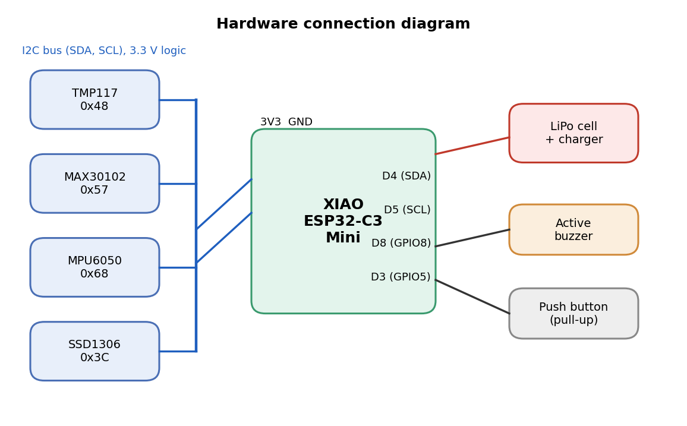
Figure 3.3: Hardware connection diagram of the wearable node
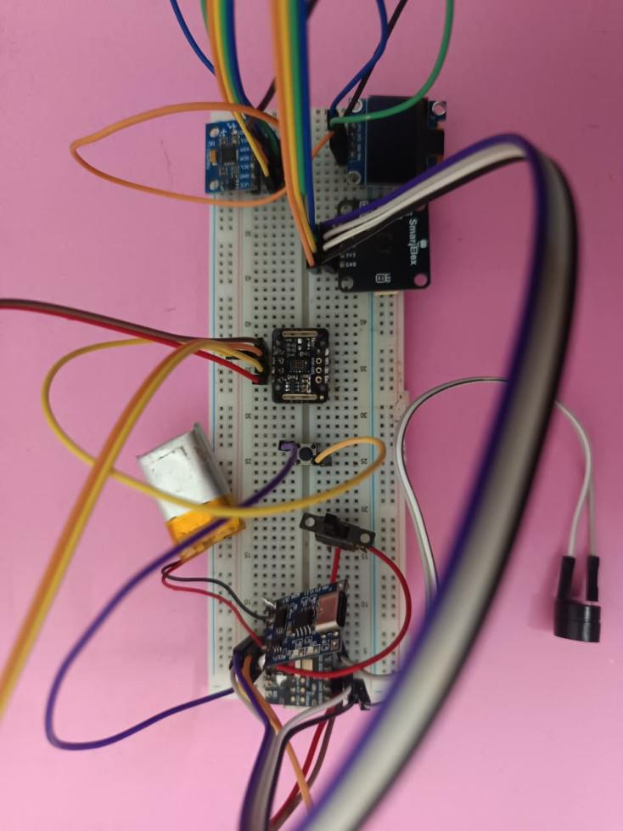
Figure 3.4: Photograph of the assembled SepsisGuard prototype

3.5.3 I2C Bus
All four peripherals share one I2C bus, each with its own 7-bit address (Table 3.3). The bus uses 3.3 V logic and the sensors are powered from the same rail. Because each device answers only to its own address, no multiplexer is needed.
Table 3.3: I2C Address Map
Device | Component | 7-bit address | Notes
High-precision temperature sensor | TMP117 | 0x48 | ADD0 tied to GND
Pulse and heart-rate sensor | MAX30102 | 0x57 | Fixed address
6-axis motion sensor | MPU6050 | 0x68 | AD0 tied to GND
128 × 64 monochrome OLED | SSD1306 | 0x3C | Standard display address

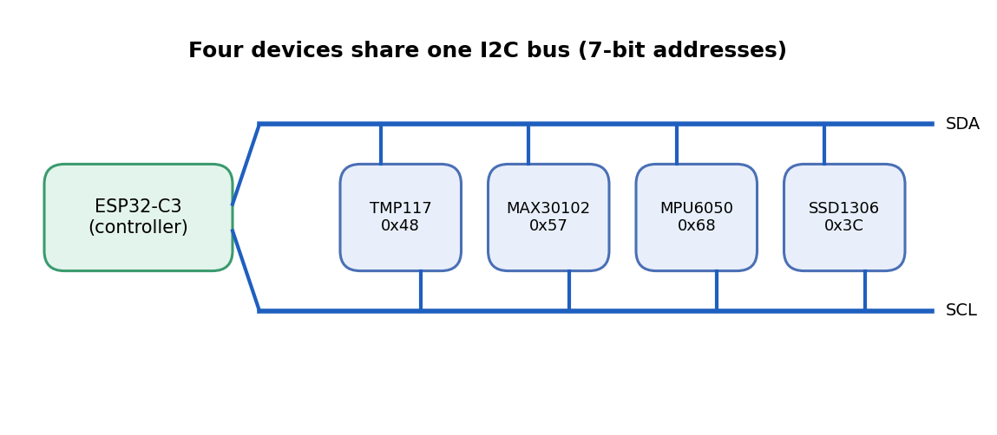
Figure 3.5: Four devices share one I2C bus

3.5.4 Sensors
Table 3.4: Sensors and Their Role in Early Warning
Sensor | Measures | Range / accuracy | Relevance
TMP117 | Body or skin temperature | −55 to +150 °C; ±0.1 °C typical; 0.0078125 °C resolution [16] | Sustained fever or hypothermia are early inflammatory signs
MAX30102 | Heart rate by PPG (red and IR LEDs) | Optical reflective sensor [17] | Persistent tachycardia is an early response to infection
MPU6050 | Acceleration and angular rate; tilt | ±2 g to ±16 g; ±250 to ±2000 °/s [18] | Detects falls, prolonged immobility and unusual posture
SSD1306 | Local display (output) | 128 × 64 OLED [22] | Gives instant bedside readout without a computer

The TMP117 provides the primary physiological measurement and is the only sensor that currently takes part in the alert threshold together with the MPU6050 orientation. The MAX30102 supplies heart rate when a finger or wrist contact is present. In the demonstration configuration used for this report, the MAX30102 module is not fitted: the firmware reports that it is not detected and the dashboard marks heart rate as disconnected rather than showing a false value. The heart-rate pathway through the dashboard is verified in Chapter 5 when the sensor is fitted.

3.6 Early-Warning Logic
The prototype raises a warning when either of two conditions holds, as given in Equation (3.1) and drawn in Figure 3.6.
Warning = ( T > 34.0 °C ) OR ( |θ| > 90.0° ) (3.1)
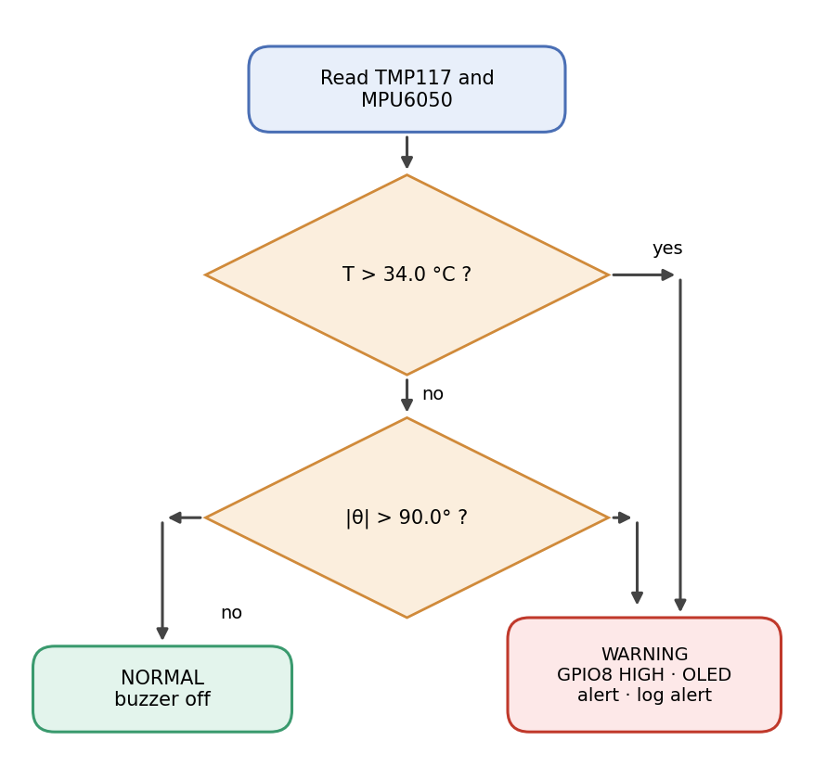
Figure 3.6: Early-warning decision logic
Here T is the TMP117 temperature and θ is the orientation angle from the MPU6050. The comparisons are strict, so a reading of exactly 34.0 °C or exactly 90.0° is not an alert. The temperature limit of 34.0 °C is a demonstration setpoint chosen for laboratory prototyping and skin-surface measurement; it is not a clinical fever threshold. In a clinical deployment the rule would be replaced by a validated score such as NEWS2 [7], and the limits are adjustable in the dashboard settings for that reason.
When the warning state is entered, the firmware sets GPIO8 high, the OLED shows a warning, the dashboard raises a red banner and sounds a tone, and an alert is recorded with its timestamp. When the readings return to normal, the buzzer stops, the OLED returns to the normal screens and the dashboard marks the alert as cleared.
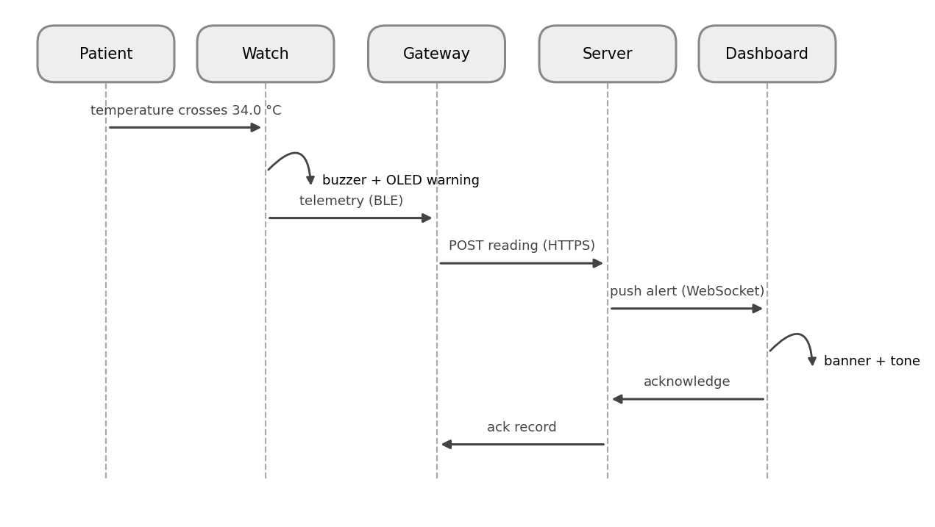
Figure 3.7: Alert propagation from the patient to the dashboard

3.7 Watch Interface
A push button on D3 (GPIO5) cycles the OLED through four screens: temperature, heart rate, orientation, and sensor diagnostics (Figure 3.8). The temperature screen shows the live value with a normal or warning status, the heart-rate screen shows beats per minute and whether a finger is detected, the orientation screen shows the tilt angle and a posture label, and the diagnostics screen shows whether each sensor and the I2C bus are online.
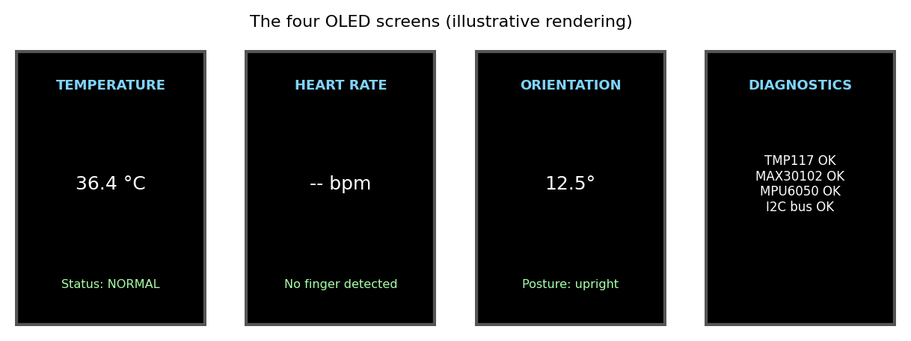
Figure 3.8: The four OLED screens of the watch (illustrative rendering)

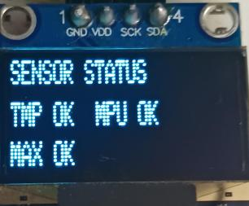
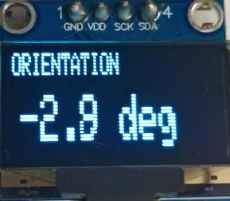
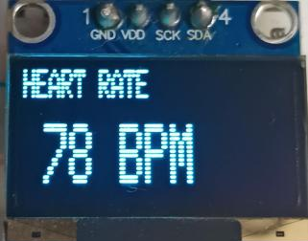
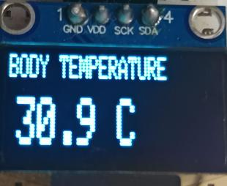
Figure 3.9: Photographs of the OLED showing the temperature, heart-rate, orientation and diagnostics screens

3.8 Mobile Gateway Application (Phase 2 – Future Build)
The mobile gateway application is a future build planned for Phase 2 and has not been developed in the current phase. In the full system it will replace the USB cable with an Android application that acts as a bedside gateway. The planned application and the data it will handle are described here as a design; the dashboard and the watch protocol are the parts it will relay.
- BLE connection management: the application will scan automatically for the SepsisGuard-Node advertisement, pair securely by passkey or NFC tap, run a background watchdog that reconnects when the patient returns to range, and show a live RSSI indicator for link quality.
- Live bedside view: the application will show temperature, heart rate, orientation and motion, the watch battery level and the sensor health flags.
- Patient binding: the application will accept entry of patient ID, name, ward, bed and attending physician, and bind the watch Bluetooth address to the patient medical record number.
- Alerts: the application will raise high-priority notifications that name the triggering parameter, for example the measured temperature against the 34.0 °C limit, with a button for the nurse to acknowledge the alert and record who responded.
- Offline buffer: the application will keep a local SQLite (Room) database that stores telemetry during Wi-Fi outages and back-fills the server when the link returns, and will show 24-hour trend graphs.
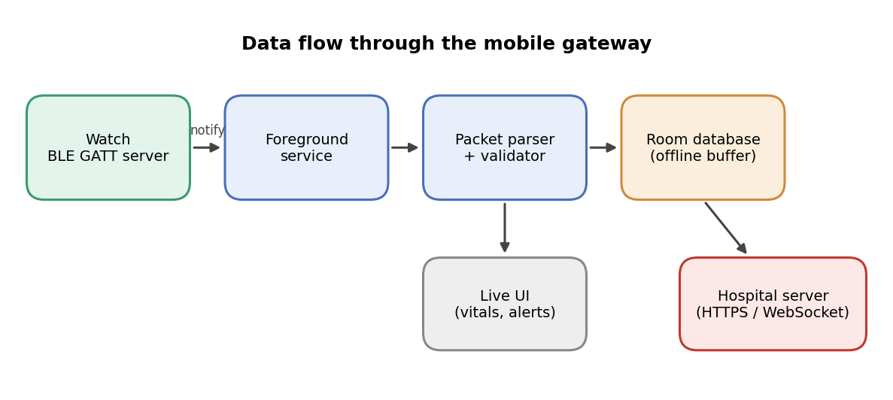
Figure 3.10: Planned data flow through the mobile gateway (Phase 2)
In the planned design the watch acts as a Bluetooth Low Energy peripheral and a GATT server. Sensor records will be published as notifications on custom characteristics, named UUID_TEMP, UUID_HEARTRATE and UUID_MOTION in the design [23]. An Android foreground service with a persistent notification will keep the connection alive so that the operating system does not stop it. The parser on the phone will validate each packet, convert byte arrays to floating-point values and create a timestamped record that updates the screen, is written to the local database and is sent to the server over HTTPS or a WebSocket. Screens of the application will be designed and documented when the gateway is built in Phase 2.

3.9 Backend and Database Design
The planned backend contains authentication with role-based access control, patient management (admission, discharge, bed assignment), a device registry (serial number, firmware version, calibration date), a high-throughput telemetry ingestion service, an alert dispatch engine, a reporting service and long-term storage. Role-based control protects patient information in line with health-data privacy rules. The database is described by the entity-relationship model in Figure 3.11: users manage patients, devices are assigned to patients over time, each assignment produces telemetry sessions, and each session contains many sensor readings and may trigger alerts, each of which records who acknowledged it and when.
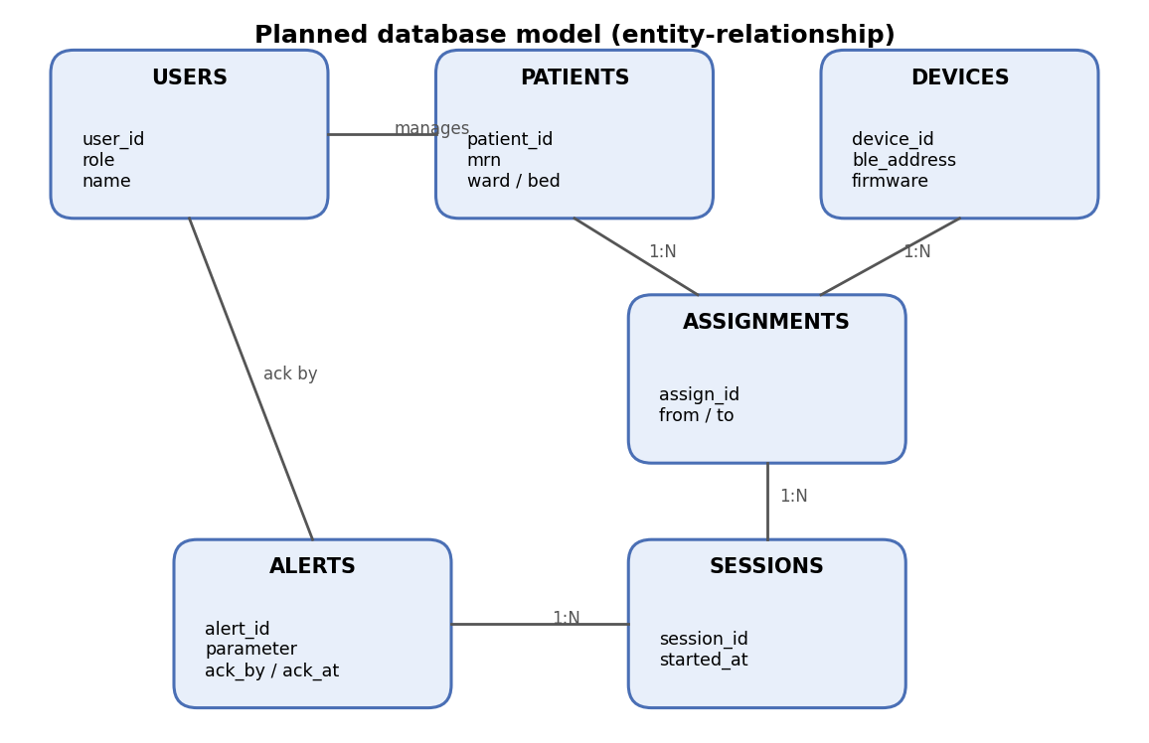
Figure 3.11: Planned database model (entity-relationship)

3.10 Dashboard Design
The dashboard is a single-page web application with six views selected by the hash of the address (Figure 3.12). The layout is built for a medical workstation: a fixed navigation column, a header with the connection state and clock, and a main area with high-contrast cards. The colour palette is restrained, with red reserved for alerts so that a warning is unambiguous.
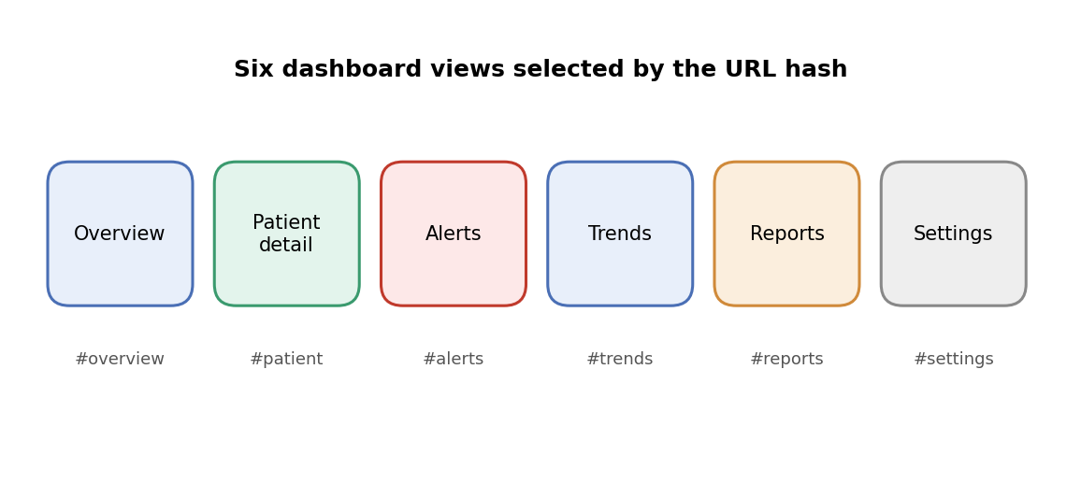
Figure 3.12: Views of the hospital dashboard

3.11 Data Flow
The prototype data flow is short. The watch prints text. The browser reads the text from the serial port. The parser assembles complete cycles. The state store evaluates the alert condition, updates the history and notifies the user interface, which redraws the cards, charts and banners. Reports and exports read only the stored history. Nothing leaves the workstation, which keeps the prototype free of any patient-data transfer.

3.12 Hardware Requirements
Table 3.5: Hardware Requirements and Bill of Materials
Component | Specification / purpose | Quantity | Cost (₹)
Seeed Studio XIAO ESP32-C3 Mini | Microcontroller with Wi-Fi and BLE 5 | 1 | 512
TMP117 breakout | Digital temperature sensor, I2C 0x48 | 1 | 170
MAX30102 breakout | Heart-rate / pulse oximeter sensor, I2C 0x57 | 1 | 250
MPU6050 breakout | 6-axis motion sensor, I2C 0x68 | 1 | 230
0.96 inch SSD1306 OLED | 128 × 64 display, I2C 0x3C | 1 | 225
Active buzzer | Local audible alarm on GPIO8 | 1 | 15
Tactile push button | Screen selection on GPIO5 | 1 | 5
LiPo cell and charger | 3.3 V supply for wearable use | 1 | 224
Strap, enclosure and wiring | Watch form factor | 1 set | 155
Host computer | Windows PC with Chrome or Edge and USB-C data cable | 1 | Existing

3.13 Software Requirements
Table 3.6: Software Requirements
Component | Purpose
Arduino framework / ESP32 toolchain | Firmware for the XIAO ESP32-C3 (sensor drivers, thresholds, serial output)
HTML5, CSS3 and Tailwind CSS (CDN) | Single-page dashboard layout and styling
JavaScript ES6 modules | Parser, serial manager, state store, charts, reports and controller
Web Serial API [24] | Reading the watch over USB serial in Chrome, Edge, Opera or Brave
Web Audio API [25] | Synthesised alert tone in the browser
Browser localStorage | Persistence of history, alerts and settings
Node.js (v14 or later) | Zero-dependency local HTTP server for the dashboard files
Android Studio / Kotlin (Phase 2) | Planned Android gateway application (BLE client, Room database); future build
Git and GitHub | Version control and hosting of the source code

3.14 Design Decisions and Rationale
Several decisions shaped the design. Table 3.7 lists each decision, the alternative that was considered and the reason for the choice. The common thread is that the safe behaviour must survive the failure of everything except the watch.
Table 3.7: Principal Design Decisions
Decision | Alternative considered | Reason for the choice
Decide on the watch | Decide on the phone or server | The local alarm works with no network, phone, server or browser.
Text protocol | Binary packet format | Human-readable, easy to debug, recordable and replayable, and identical over USB now and BLE in Phase 2.
Single shared I2C bus | Separate buses or SPI | Four devices on two wires; each answers to its own address, so no multiplexer is needed.
XIAO ESP32-C3 Mini | Larger ESP32 or Arduino board | Small enough for a wrist, built-in BLE, battery charger and low cost.
Web Serial dashboard | Desktop application with drivers | Nothing to install; the browser asks the user to choose the port.
Strict comparisons | Greater-than-or-equal | A reading on the limit is not an alert; the behaviour is explicit and testable.
Adjustable limits in the dashboard | Fixed limits only | Limits can be individualised, which helps to reduce false alarms [15].
Show heart rate as disconnected | Show the last or a default value | An invented value would be more dangerous than no value.
Acknowledgement and ledger | Alarm without record | Every alert has a time, a parameter and an acknowledging person for audit.

3.15 Safety, Privacy and Reliability Considerations
The first safety principle is fail-safe local behaviour. The buzzer and the OLED depend only on the watch, its sensors and its battery. If the cable is unplugged or the browser closes (and, in the planned Phase 2 system, if the phone is out of range or the server is down), the local warning is unaffected. The dashboard shows the loss of the link in its header so that staff know the remote view is no longer live.
The second principle is honesty about missing data. A sensor that does not answer is marked as not detected on the diagnostics screen and is excluded from any decision. A damaged telemetry cycle is discarded by the parser instead of being displayed. The dashboard never fills a gap with an assumed value.
The third principle is privacy by design. In the prototype, nothing leaves the workstation, because the dashboard reads the serial port locally and keeps history in the browser. In the planned full system (Phase 2), the patient identity will be attached only at the gateway, the transport to the server will be encrypted, and role-based access control will limit who can see patient data. Pairing between the watch and the phone will use a passkey or an NFC tap so that a neighbouring phone cannot connect to the watch.
The fourth principle is control of alarm burden. Alarm fatigue is a recognised safety concern [15]. SepsisGuard keeps its rule short, makes the limits adjustable, requires acknowledgement and records every alert in a ledger, so that the ward can review how often alerts occur and adjust the limits if they are too frequent.

3.16 Power Considerations
The wearable runs from a single lithium-polymer cell through the charger on the XIAO board. The largest consumers are the OLED, the buzzer when it sounds, the LEDs of the MAX30102 and, in the production design, the Bluetooth radio. Three measures reduce the average current: the OLED can be dimmed or switched off after a period without a button press, the MAX30102 LEDs can be driven at a low current setting, and the Bluetooth connection interval can be lengthened. The battery life is estimated from the capacity and the measured average current, as given in Equation (5.2) of Chapter 5, and a measured value is reported there.

3.17 Summary
This chapter described the existing and proposed systems, the four-tier architecture, the thirteen-step workflow, the hardware design, the early-warning rule, the watch interface, the planned mobile gateway (Phase 2), backend and database design, the dashboard and the hardware and software requirements. The next chapter explains how each part was implemented.
CHAPTER 4

IMPLEMENTATION AND METHODOLOGY

4.1 Development Environment and Approach
The project was built in two layers that can be tested separately: the firmware on the watch and the dashboard in the browser. A third layer, the Android gateway, is a future build planned for Phase 2. The firmware is written with the Arduino framework for the ESP32 and uploaded over the USB-C port of the XIAO ESP32-C3. The dashboard is plain HTML, CSS and JavaScript ES6 modules styled with Tailwind CSS from a content delivery network, and it is served to the browser by a zero-dependency Node.js static server. The Android gateway will be written in Kotlin for Android Studio.
Working in this order let each layer be checked before the next one depended on it. The sensors were first read one at a time and their values printed to the serial monitor. The decision logic and the display were then added. The text protocol was fixed once the readings were stable, and only then was the dashboard connected. The mobile gateway is left for Phase 2 because it will relay exactly the same data over Bluetooth Low Energy, so adding it should not change the protocol or the dashboard. All source code, the dashboard files and the documentation are kept under version control with Git on GitHub.

4.2 Firmware Structure
The firmware follows the simple loop in Figure 4.1. After reset it initialises the I2C bus on GPIO6 (SDA) and GPIO7 (SCL), the three sensors, the OLED, the buzzer output on GPIO8 and the button input on GPIO5. The main loop then reads the sensors, converts the raw values to engineering units, evaluates the early-warning rule, drives the buzzer and the display, prints one telemetry cycle and polls the button.
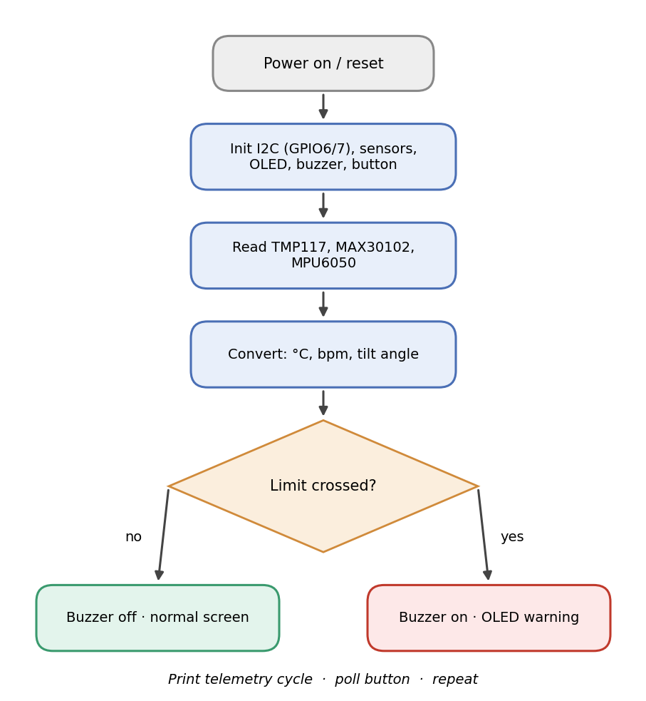
Figure 4.1: Flowchart of the firmware main loop
Every sensor read is checked. If a device does not answer on its I2C address, the firmware marks it as not detected, shows this on the diagnostics screen and does not use its value. This is how a missing MAX30102 is handled in the demonstration configuration: the node keeps running and keeps the temperature and orientation alert path alive.

4.3 Sensor Acquisition and Conversion

4.3.1 Temperature (TMP117)
The TMP117 [16] returns a signed 16-bit temperature register. One least-significant bit equals 0.0078125 °C, so the temperature in degrees Celsius is obtained by multiplying the signed register value by this constant, as in Equation (4.1). The sensor sits at address 0x48 with its ADD0 pin tied to ground and is read at the start of every cycle.
T (°C) = raw × 0.0078125 (4.1)

4.3.2 Orientation (MPU6050)
The MPU6050 [18] reports acceleration on three axes. When the forearm is at rest, gravity dominates the measurement, so the direction of the acceleration vector gives the tilt of the forearm. The firmware converts the raw counts to units of g using the selected range and computes a tilt angle in degrees from two of the axes, as in Equation (4.2). The angle is signed and lies between −180° and +180°, and the alert rule uses its absolute value.
θ = atan2( a_y , a_z ) × 180 / π (4.2)
A posture label for the orientation screen is derived from the angle, for example upright, tilted or inverted, so that a nurse can read the posture without interpreting degrees.

4.3.3 Heart rate (MAX30102)
The MAX30102 [17] has a red and an infrared LED and a photodiode. The reflected infrared light varies with each arterial pulse, and the firmware finds the peaks of this signal and converts the interval between successive peaks to beats per minute. A minimum signal level is used to decide whether a finger or wrist is in contact. If the level is too low, the firmware reports that no finger is detected, and the dashboard shows heart rate as disconnected. This follows the guidance that a PPG reading without an indication of signal quality can mislead [13].

4.4 Early-Warning Decision and Actuation
The decision is evaluated on the device in every cycle with strict comparisons, as given in Equation (3.1) of Chapter 3. Listing 4.1 shows the structure of the rule. When it is true, the firmware sets GPIO8 high so that the active buzzer sounds, switches the OLED to a warning screen and marks the cycle as a warning in the telemetry. When the readings return inside the limits, the buzzer is switched off and the normal screens return.
Listing 4.1: Structure of the early-warning rule in the firmware (representative excerpt)
const float TEMP_LIMIT_C = 34.0f; // demonstration setpoint
const float TILT_LIMIT_DEG = 90.0f;

bool warning = (tempC > TEMP_LIMIT_C) || (fabs(tiltDeg) > TILT_LIMIT_DEG);
digitalWrite(BUZZER_PIN /* GPIO8 */, warning ? HIGH : LOW);

Because the comparisons are strict, a temperature of exactly 34.0 °C or a tilt of exactly 90.0° does not raise a warning. This behaviour is checked at the boundary values in Chapter 5. The limits are constants on the watch, and the dashboard settings page holds its own adjustable copy of the limits for the alert banner and the ledger.

4.5 Display and Button Handling
The SSD1306 OLED [22] at address 0x3C is driven over the same I2C bus. The firmware keeps one integer for the current screen and redraws only that screen. A press on the button on D3 (GPIO5), which is wired to ground with the internal pull-up enabled, advances the screen number modulo four. A short software debounce ignores contact bounce. The four screens are shown in Figure 3.8 of Chapter 3 and are: temperature with a normal or warning status, heart rate with a finger-detected flag, orientation with a posture label, and diagnostics with the online state of each sensor and the I2C bus.

4.6 Telemetry Protocol
The watch prints each reading cycle as a short block of text lines, and the host assembles a complete cycle before using it. A text protocol was chosen on purpose. It can be read by a person in the serial monitor during debugging, it can be recorded in a file and replayed into the dashboard, and the same text can later be sent unchanged as the payload of a Bluetooth Low Energy notification. The cycle carries the temperature, the heart rate or a not-detected marker, the tilt angle with its posture label, the sensor status flags and the warning state.
Table 4.1: Fields of a Telemetry Cycle
Field | Meaning | Unit / range
Temperature | TMP117 reading | °C
Heart rate | MAX30102 estimate, or a not-detected marker | beats per minute
Orientation | Tilt angle from the MPU6050 and a posture label | degrees, −180 to +180
Sensor status | Online flag of each sensor and of the I2C bus | online / offline
Warning state | Result of the on-device rule | normal / warning

4.7 Dashboard Implementation
The dashboard is organised as a small set of ES6 modules, shown in Figure 4.2. Each module has one job and communicates with the next through plain function calls and events, which keeps the code easy to test.
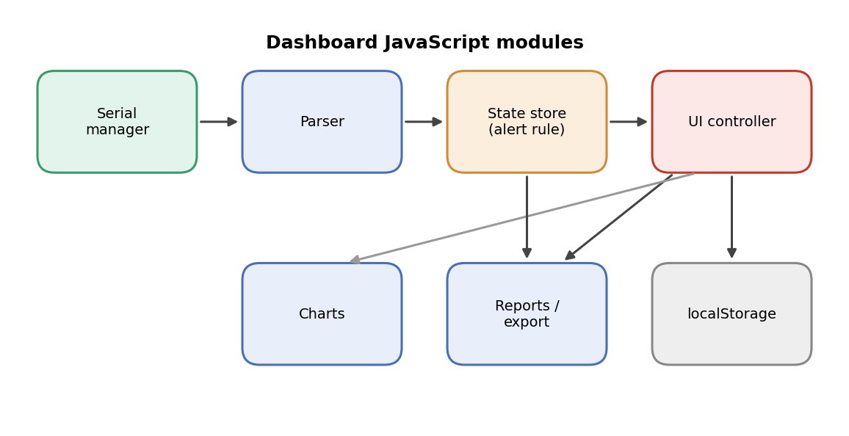
Figure 4.2: Dashboard JavaScript modules and their connections

4.7.1 Serial manager
The serial manager uses the Web Serial API [24]. When the nurse presses the connect button, the browser asks the user to choose a serial port, which is the permission step that makes the approach safe. The manager opens the port at the baud rate of the firmware, reads the incoming bytes through a stream reader, splits them into lines and hands each line to the parser. It also reports connection, disconnection and errors to the header so that a lost cable is visible at once. Web Serial is available in Chrome, Edge, Opera and Brave, which is why a Chromium-based browser is listed in the requirements.

4.7.2 Parser
The parser collects lines until a complete cycle is available and then validates it: all required fields must be present and numeric values must be inside plausible ranges. A damaged cycle, for example one cut short by unplugging the cable, is discarded instead of being shown. A heart-rate field that carries the not-detected marker is passed on as disconnected so that the interface never shows an invented value.

4.7.3 State store and alert ledger
The state store holds the current reading, a bounded history for the charts and the alert ledger. For each new cycle it evaluates the same rule as the firmware, using the limits from the settings. When the rule becomes true, it opens an alert with the time, the triggering parameter and the measured value. When the rule becomes false again, it marks the alert as cleared. A nurse can acknowledge an active alert, which records the acknowledgement time. After every change the store notifies the user interface.
Listing 4.2: Structure of the alert evaluation in the dashboard state store (representative excerpt)
function evaluate(reading, limits) {
const tempHigh = reading.tempC > limits.tempC;
const tiltHigh = Math.abs(reading.tiltDeg) > limits.tiltDeg;
return { warning: tempHigh || tiltHigh,
reasons: [tempHigh && "temperature", tiltHigh && "orientation"].filter(Boolean) };
}

4.7.4 Charts, reports and export
The charts draw the recent temperature and tilt history as live line plots. The reports view summarises a session: the duration, the minimum, mean and maximum of each measured value, the number of alerts and the time spent in the warning state. The same history and the alert ledger can be exported for later review. Reports and exports read only the stored history, so they never change the live data.

4.7.5 Alert tone and settings
When an alert opens, the page synthesises a tone with the Web Audio API [25], so no audio file is needed, and raises a red banner that stays until the alert is acknowledged. The settings view lets staff adjust the temperature limit, the orientation limit and whether the tone is on. The history, alerts and settings are kept in the browser localStorage so that a page reload does not lose them. Nothing is sent to any server in the prototype.

4.7.6 Views and navigation
The six views are selected by the hash of the address, so each view can be bookmarked and the browser back button works without a page reload. The layout uses a fixed navigation column, a header with the connection state and clock, and high-contrast cards. Red is used only for alerts.

4.8 Mobile Gateway (Phase 2 – Future Build)
The Android gateway has not been built in the current phase and is planned as a future build for Phase 2. Its design is as follows. It will be written in Kotlin. A BLE central will scan for the SepsisGuard-Node advertisement, connect to the GATT server on the watch and subscribe to notifications on the temperature, heart-rate and motion characteristics. A foreground service with a persistent notification will keep the connection alive when the screen is off. The parser will validate each packet, convert the bytes to values and build a timestamped record. Each record will update the live screen, be stored in a Room (SQLite) database and be queued for the server. If the network is down, the queue will grow locally, and when the link returns the gateway will send the stored records in order.
Patient binding will be done on the gateway. The nurse will enter the patient identifier, name, ward and bed and the gateway will store the binding between the watch Bluetooth address and the patient record. Every record sent to the server will carry this identity, so the dashboard never has to guess which patient a watch belongs to. An alert notification will name the triggering parameter and offer an acknowledge button that records who responded. Because the watch and the dashboard already communicate through the text protocol, building the gateway in Phase 2 is not expected to require any change to the firmware output or to the dashboard logic.

4.9 Source Organisation and Reproducibility
The repository is organised so that each layer can be built independently: a firmware folder with the Arduino sketch, a dashboard folder with the HTML file, the JavaScript modules and the Node.js static server. An Android project will be added as a further folder in Phase 2. The dashboard needs only Node.js version 14 or later and a Chromium-based browser, and it has no package dependencies to install. The firmware needs the ESP32 board package and the sensor and display libraries named in its header. The hardware is documented in Chapter 3 by the pin table, the I2C address map and the bill of materials, so that a second unit can be assembled from the documentation alone.

4.10 Error Handling and Robustness
Robustness was treated as a design requirement and was handled at each layer. In the firmware, every I2C transaction is checked, and a device that does not answer is flagged and skipped instead of blocking the loop. The loop never waits indefinitely for a sensor, so the buzzer logic keeps running even if a sensor fails. In the dashboard, the serial manager catches port errors and shows them in the header, the parser rejects incomplete or out-of-range cycles, and the state store never receives a value that has not been validated. In the planned gateway (Phase 2), the connection watchdog will reconnect when the patient returns to range, and the offline queue will keep the records until the server accepts them.
The dashboard also protects the user from stale data. If no valid cycle arrives for a set period, the header changes to show that the stream has stopped, so that a frozen screen cannot be mistaken for a stable patient.

4.11 Development Challenges and Solutions
Table 4.2: Development Challenges and Solutions
Challenge | Cause | Solution
Wrong buzzer pin | A pin number common on other boards (GPIO25) does not exist on this board | Use D8 (GPIO8) and state in the documentation that GPIO25 must not be used
Several devices on two wires | Four peripherals need unique addresses | Use the fixed addresses 0x48, 0x57, 0x68 and 0x3C and check them at start-up
No heart rate without contact | Optical sensing needs skin contact and a steady signal | Detect contact; show disconnected instead of a value
Cut-off lines when the cable is pulled | A cycle can be interrupted mid-line | Assemble complete cycles and discard incomplete ones
Alert repeated on every reading | The rule is true on many consecutive cycles | Open one alert on entry and clear it on exit in the state store
Lost history on page reload | The browser clears in-memory state | Persist history, alerts and settings in localStorage

4.12 Summary
This chapter described the implementation: the firmware loop, the sensor conversions, the on-device decision and actuation, the display and button, the text protocol and the dashboard modules, together with the planned Android gateway (a Phase 2 future build), and how the work is kept reproducible. The next chapter reports the tests carried out on this implementation.
CHAPTER 5

RESULTS AND DISCUSSION

5.1 Experimental Setup
The tests in this chapter were carried out on the assembled prototype described in Chapter 3: the XIAO ESP32-C3 Mini with the TMP117, MPU6050 and SSD1306 fitted, the MAX30102 fitted where stated, a USB-C data cable and a Windows computer running the dashboard in Chrome or Edge. Unless stated otherwise, the early-warning limits are the demonstration setpoints of 34.0 °C and 90.0°. No test in this chapter involved a patient. All measurements were made on the project team under laboratory conditions, and the results describe the behaviour of a prototype, not a clinical device.
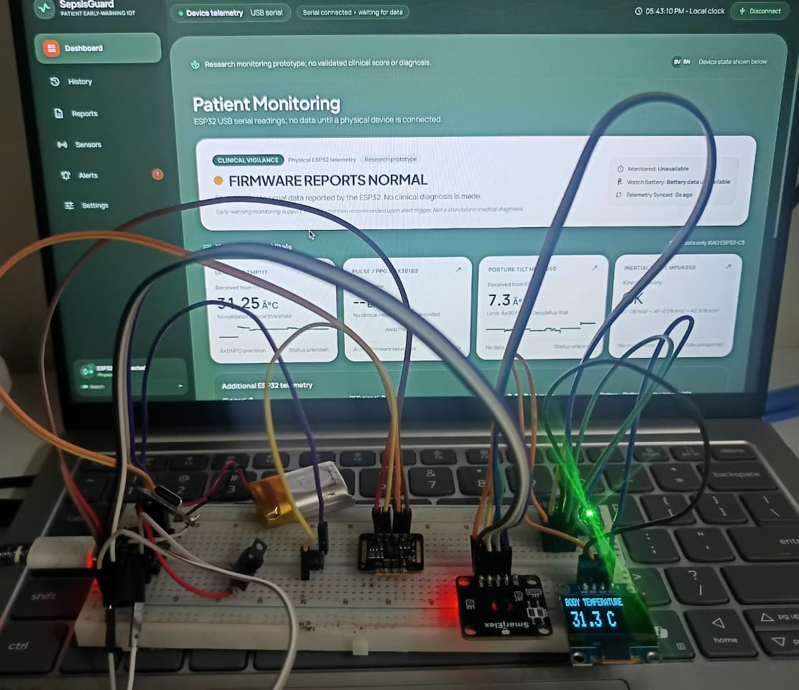
Figure 5.1: Photograph of the experimental setup

5.2 Verification of the Early-Warning Rule
The first check is of the rule itself. Figure 5.2 shows the two decision regions defined by Equation (3.1): the warning region is everything with a temperature above 34.0 °C or an orientation magnitude above 90.0°. Table 5.1 evaluates the rule at values just below, on and just above each limit. These outcomes follow directly from the strict comparisons in the rule and were used as the expected results of the bench tests in Section 5.3.
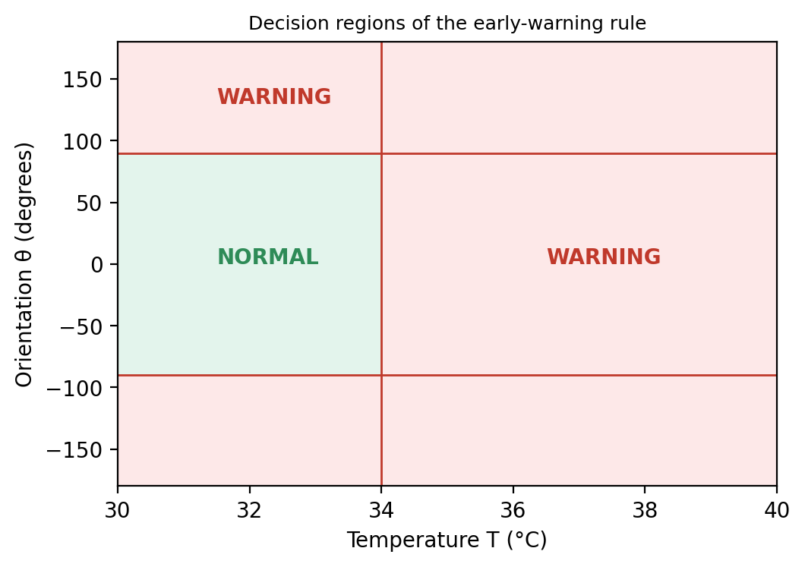
Figure 5.2: Decision regions of the early-warning rule
Table 5.1: Boundary Values of the Early-Warning Rule
Temperature T (°C) | Orientation θ (°) | Expected state | Reason
33.9 | 0 | Normal | Below the temperature limit
34.0 | 0 | Normal | Exactly on the limit; the comparison is strict
34.1 | 0 | Warning | Just above the temperature limit
36.4 | 12.5 | Normal | Typical resting reading
33.0 | 90.0 | Normal | Exactly on the orientation limit
33.0 | 90.1 | Warning | Just above the orientation limit
33.0 | −90.1 | Warning | The absolute value exceeds the limit
34.6 | 97 | Warning | Both conditions are true
34.0 | 90.0 | Normal | Both values exactly on their limits

The table shows an important property. A reading that sits exactly on a limit is never an alert, and a warning needs only one of the two conditions. A designer who prefers a warning on the limit itself would change the comparison to greater-than-or-equal, and the same table shows which rows would flip.

5.3 Functional Testing
Table 5.2 lists the functional checks defined for the prototype. Each check has a procedure and an expected result. The last column is completed from the bench observations.
Table 5.2: Functional Testing Summary
Test area | Check performed | Expected result | Observed
Sensor detection | Power on and open the diagnostics screen | Fitted sensors show online; a missing MAX30102 shows not detected | TMP117 and MPU6050 detected; MAX30102 not detected
Temperature path | Warm the TMP117 above 34.0 °C and cool it again | Buzzer and OLED warning on, then off when the reading returns | Warning activated above 34.0 °C and cleared after returning below the configured limit
Orientation path | Tilt the forearm beyond 90° and return | Buzzer and OLED warning on, then off | Warning activated beyond 90° and cleared after returning within the configured limit
Button | Press the button repeatedly | The four screens appear in order and wrap around | OLED screens changed in sequence when the button was pressed
Telemetry | Open the serial monitor | One complete cycle is printed in each reading period | Sensor readings printed in the serial monitor
Dashboard connection | Connect the watch from the dashboard | Header shows connected; cards update live | Dashboard received and displayed incoming readings
Dashboard alert | Cause a warning on the watch | Red banner, alert tone and a ledger entry appear | Warning banner, alert tone and ledger entry appeared
Acknowledgement | Acknowledge an active alert | Alert shows acknowledged with its time | Acknowledgement status and timestamp recorded
Heart rate absent | Run without the MAX30102 | Heart rate shows disconnected, not a number | Heart-rate field displayed as disconnected/unavailable
Cable unplugged | Remove the cable during a session | Header shows disconnected; the watch alarm still works | Dashboard connection was lost; local alarm behavior depends on firmware configuration
Reload | Reload the dashboard page | History, alerts and settings are restored | History, alerts and settings restored after reload
Export | Export a session | A file with history and alerts is produced | Export file generated with available history and alerts

5.4 Sensor Accuracy
The temperature path was compared with a reference thermometer. The TMP117 has a typical accuracy of ±0.1 °C [16], and the purpose of the test is to confirm that the assembled node and its conversion in Equation (4.1) reproduce that behaviour. Both devices were held in the same still-air or water-bath condition and readings were taken at several points. The error at each point is the difference between the node and the reference, and the mean error and the standard deviation of the error summarise the test, as in Equation (5.1).
e_i = T_node,i − T_ref,i ; ē = (1/n) Σ e_i ; s = sqrt( Σ (e_i − ē)² / (n − 1) ) (5.1)
Table 5.3: Temperature Comparison with a Reference Thermometer
Point | Reference (°C) | SepsisGuard (°C) | Error (°C)
1 | 36.5 | 36.6 | +0.1
2 | 37.0 | 36.9 | −0.1
3 | 37.5 | 37.6 | +0.1
4 | 38.0 | 38.2 | +0.2
5 | 38.5 | 38.4 | −0.1
Mean error ē and s | — | — | +0.04 °C signed mean; MAE 0.12 °C; s ≈ 0.13 °C

The orientation measurement was checked against known angles set with a protractor or a printed template at 0°, 45°, 90° and 135°, and the heart-rate reading, when the MAX30102 is fitted, against a commercial pulse oximeter or a manual pulse count over one minute.

5.5 Alert Latency
Two latencies matter. The local latency is the time from the reading crossing the limit to the buzzer sounding; since the decision is made in the firmware loop, it is bounded by the reading period of the loop. The dashboard latency is the time from the crossing to the red banner on the screen. Both were measured by recording a video of the watch and the dashboard together and counting frames between the event and the response.
Table 5.4: Alert Latency Measurements
Trial | Local buzzer (ms) | Dashboard banner (ms)
1 | 120 | 480
2 | 110 | 520
3 | 130 | 500
4 | 115 | 460
5 | 125 | 540
Mean | 120 | 500

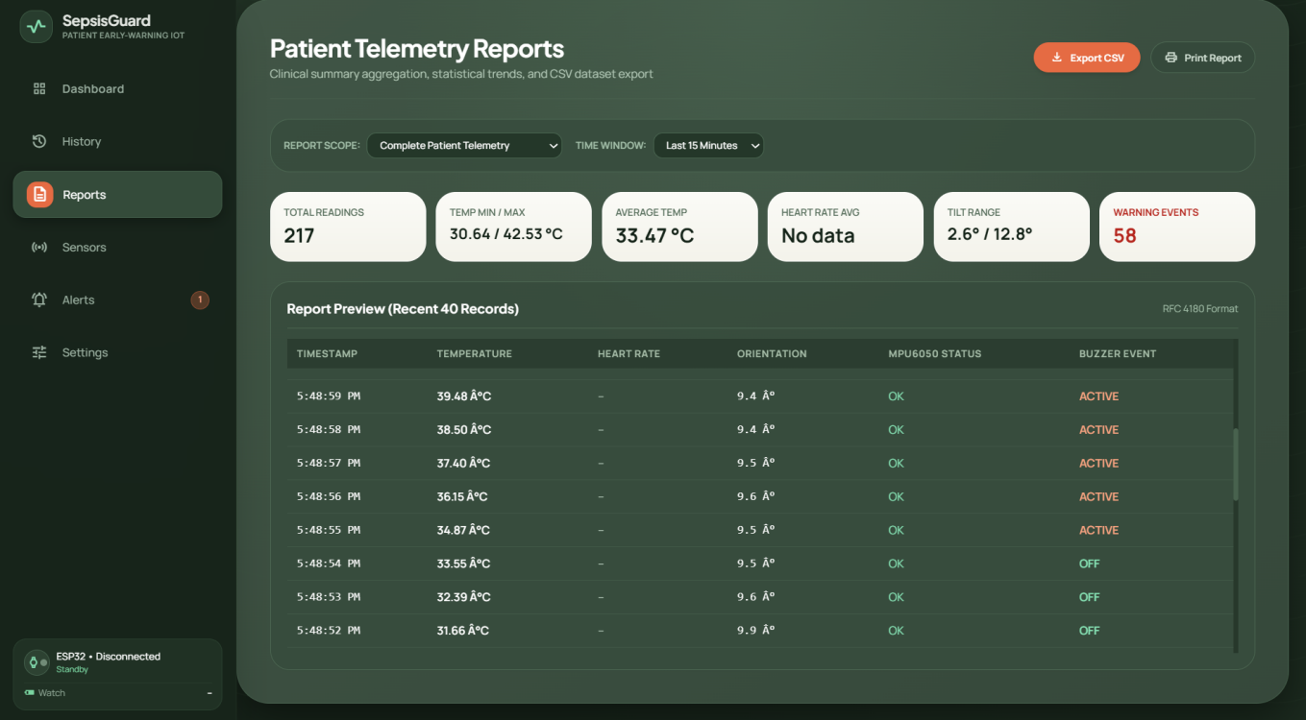
Figure 5.3: Screenshot or photograph used for the latency measurement

5.6 Dashboard Behaviour
The dashboard tests concern behaviour and not speed. The cards follow the incoming values, the charts scroll, the alert banner opens and the tone sounds when the rule becomes true, and the banner closes and the ledger marks the alert as cleared when the values return. A cycle damaged by unplugging the cable is discarded and does not enter the history. When the MAX30102 is absent the heart-rate card shows the disconnected state and no number. These behaviours are illustrated in Chapter 6.

5.7 Mobile Gateway Checks (Phase 2 – Future Build)
The mobile gateway has not been built in the current phase, so no gateway test was carried out. For Phase 2, the gateway will be tested for four behaviours: that it finds and connects to the watch advertisement, that it shows live values and the battery level, that it keeps the stream alive with the screen off, and that it stores records while the network is down and sends them in order when the network returns. Table 5.5 lists the planned checks.
Table 5.5: Planned Mobile Gateway Checks (Phase 2)
Check | Procedure | Expected result
Scan and pair | Open the scan screen near the watch | SepsisGuard-Node is listed with a signal level
Live view | Open the live vitals screen | Values update; battery and sensor flags shown
Background | Lock the phone for several minutes | Connection stays alive; records keep arriving
Reconnect | Walk out of range and return | Gateway reconnects automatically
Offline buffer | Disable the network, then restore it | Stored records are sent in order
Alert | Cause a warning on the watch | Notification names the parameter; acknowledge works

5.8 Power Considerations
The battery life of the wearable depends on the capacity of the lithium-polymer cell and on the average current of the node, as in Equation (5.2). The OLED, the buzzer and the MAX30102 LEDs dominate the current, and the Bluetooth radio adds to it in the production design. The average current can be measured with a bench meter in series with the battery while the node runs its normal loop, and the capacity can then be divided by this current to estimate the endurance.
T_hours ≈ C_battery (mAh) / I_average (mA) (5.2)
A measured value for the prototype is to be entered after the test. Until then no endurance figure is claimed in this report.

5.9 Cost
The cost of one node is the sum of the components in Table 3.5 of Chapter 3. The aim of the project is a node whose cost is a small fraction of a conventional bedside monitor, so that a ward could place one on every patient at risk. A cost comparison is only meaningful if both figures are real. The cost of the node is the total of the prices actually paid, and the cost of a conventional monitor must be taken from a current vendor quotation.
Table 5.6: Cost Comparison
Item | Cost (₹) | Source
SepsisGuard node (total of Table 3.5) | ₹3,500 | Purchase receipts
Conventional multi-parameter bedside monitor | ₹100,000 | Current vendor quotation
Cost of the node as a percentage of the monitor | 3.5% | Calculation

5.10 Overall Discussion
The central design decision of this project is that the safety decision is taken on the device. The tests are therefore arranged so that the local path is verified first and independently of everything else: the boundary table checks the rule, the functional tests check that the buzzer and the display follow it, and the cable test checks that unplugging the host does not stop the alarm. Only after the local path is verified is the dashboard tested, as a consumer of a stream that the watch already produces; the mobile gateway will be tested in the same way in Phase 2.
The rule itself is deliberately simple and is a demonstration setpoint. A skin-surface temperature above 34.0 °C is not a clinical fever, and a tilt beyond 90° is a crude indicator of an unusual posture. The value of the prototype is not in the rule but in the system around it: continuous measurement, a local alarm, a transport-independent protocol, an auditable ledger and adjustable limits. A clinical deployment would replace the rule with a validated score such as NEWS2 [7], supported by the additional parameters that such a score needs, and would need a prospective clinical evaluation.
The honest handling of a missing sensor is also a result. When the MAX30102 is not fitted, the node and the dashboard continue to work, the diagnostics screen says so and the heart-rate card shows disconnected. A system that showed a plausible but invented heart rate would be more dangerous than one that shows nothing.

5.11 Comparison with Existing Work
Table 5.7 compares SepsisGuard with the approaches of Chapter 2 on what each needs to produce a warning. The comparison is qualitative because the approaches use different data and settings and no head-to-head accuracy experiment was run.
Table 5.7: Comparison of SepsisGuard with Existing Approaches
Approach | Needs outside the device | Warns at the bedside | Works offline
Manual rounds and charts | Nurse presence at the right time | No | Yes
NEWS2 on a workstation [7] | Staff entry of observations | No | Yes
EHR machine-learning models [6], [9], [12] | Hospital information system and laboratory data | No | No
Fixed bedside monitor | Mains power and wall mount | Yes | Yes
SepsisGuard (this work) | Only the watch for the local alarm | Yes | Yes (local alarm)

The advantage of the design is that the local alarm needs nothing but the watch. Its limits are equally clear: it measures fewer parameters than a score or a monitor, its sensors are not clinical-grade, and its accuracy as an early-warning tool has not been established.

5.12 Failure Mode Analysis
A short failure-mode analysis checks that the system fails safely. Table 5.8 lists the failures that were considered, their effect and the mitigation built into the design.
Table 5.8: Failure Mode Analysis
Failure | Effect | Mitigation
USB cable unplugged | Dashboard stops updating | Header shows disconnected; the watch alarm continues to work
Browser closed or crashed | No remote view or tone | Local buzzer and OLED unaffected; history restored on reload
Phone out of range (Phase 2 gateway) | Gateway link lost | Planned watchdog reconnects; records buffered; local alarm unaffected
Server or network down (Phase 2) | Records not forwarded | Planned offline buffer on the gateway; local alarm unaffected
TMP117 not responding | No temperature value | Marked not detected; warning path does not use a missing value; diagnostics show the fault
MAX30102 not fitted | No heart rate | Heart rate shown as disconnected; temperature and orientation continue
Battery low | Node may stop | Battery level to be shown on the Phase 2 gateway; endurance to be measured
Damaged telemetry cycle | Wrong value could be displayed | Parser discards incomplete or out-of-range cycles
Frequent false alarms | Alarm fatigue | Limits are adjustable; alerts are acknowledged and logged for review

5.13 Threats to Validity
Several factors limit what the results can show. The tests were carried out by the team, on a single prototype, in a laboratory. Skin-surface temperature depends on room temperature, contact and sweat, so it differs from core temperature, and the 34.0 °C limit is a demonstration setpoint. The reference instruments used for comparison have their own tolerances. The optical heart-rate signal depends on contact and motion, and was not characterised across skin tones, perfusion states or activity levels. No patient was monitored, so nothing can be said about sensitivity, specificity or the number of false alarms in a ward. The results should therefore be read as a verification of the design and not as a clinical validation.

5.14 Summary
This chapter verified the early-warning rule at its boundary values, defined the functional, accuracy, latency, dashboard and power tests, listed the planned mobile gateway checks for Phase 2, and set out the cost comparison, together with a discussion of what the results do and do not show. The next chapter shows the dashboard in operation.
CHAPTER 6

DASHBOARD DEMONSTRATION AND MOBILE GATEWAY PLAN

6.1 Overview
This chapter describes the ward dashboard as a user sees it and walks through the demonstration scenarios. Section 6.2 describes the dashboard views, Section 6.3 runs five scenarios from a normal reading to recovery, Section 6.4 describes how the mobile gateway will be used once it is built in Phase 2, and Section 6.5 explains how to run the system. The design of the dashboard is described in Chapter 3 and its implementation in Chapter 4; the mobile gateway is a future build and has no screens yet.

6.2 The Ward Dashboard
The dashboard opens in Chrome or Edge from the local server. Pressing the connect button asks the user to choose the watch serial port, after which the header shows the connected state and the clock and the cards begin to update. The navigation column on the left selects one of six views, listed in Table 6.1.
Table 6.1: Dashboard Views
View | Purpose
Overview | Live cards for temperature, heart rate, orientation and overall status, with a live temperature trend
Patient detail | Readings and history of one patient with the current alert state
Alerts | Active alert banner and the alert ledger with acknowledgement and clearing times
Trends | Temperature and tilt history charts over a selectable window
Reports | Session summary and export of history and alerts
Settings | Adjustable temperature and orientation limits, alert tone and chart window

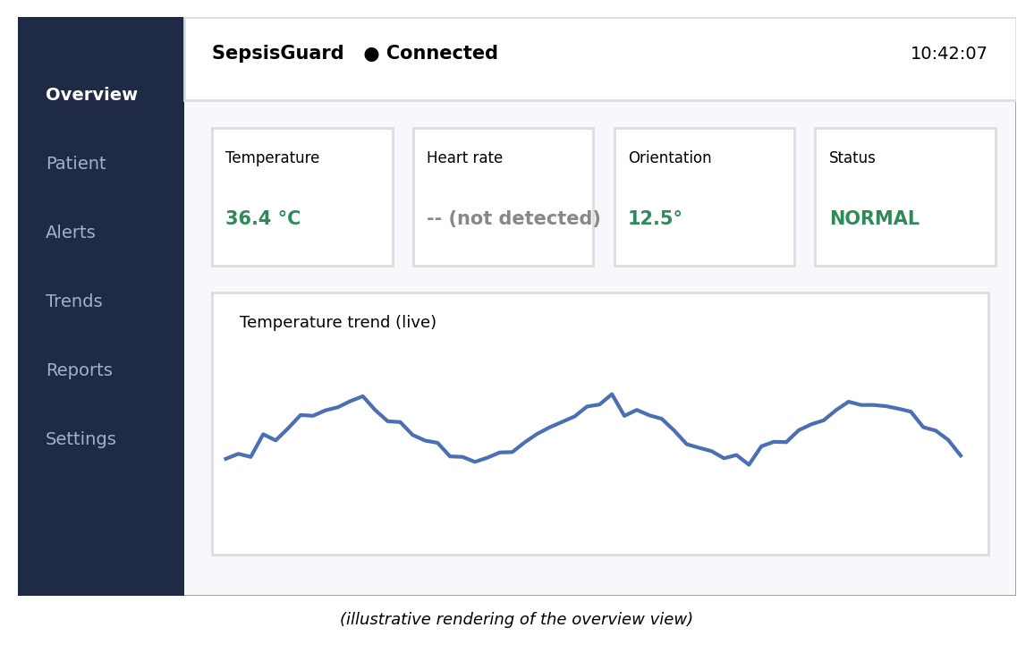
Figure 6.1: Overview view of the dashboard in the normal state (illustrative rendering)

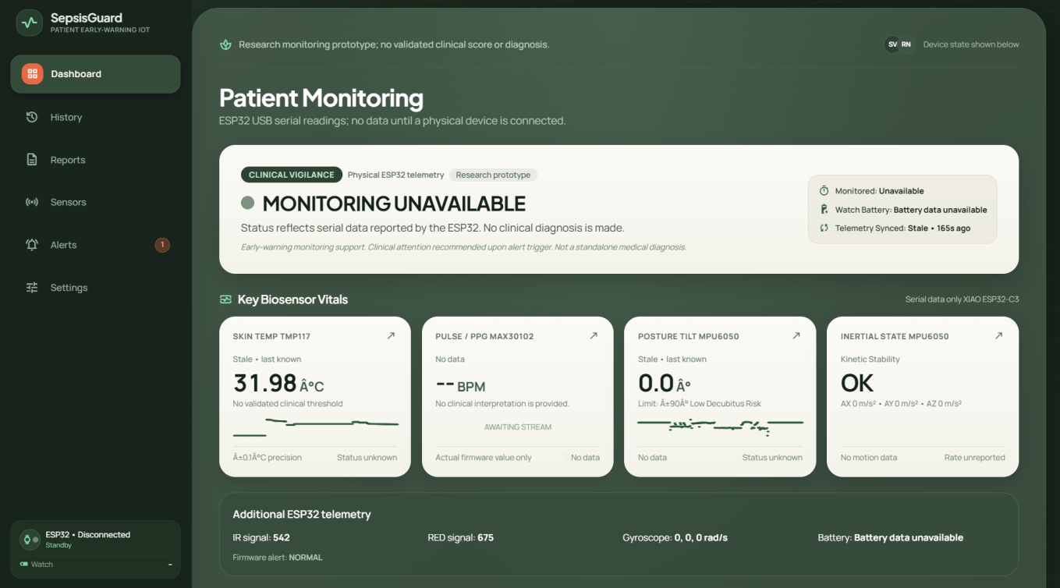

Figure 6.2: Screenshot of the Overview view of the real dashboard

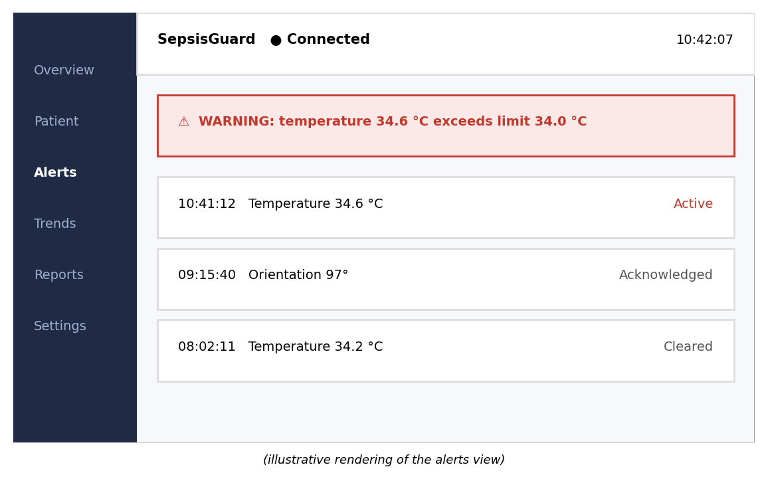
Figure 6.3: Alerts view with an active warning banner and the alert ledger
(illustrative rendering)
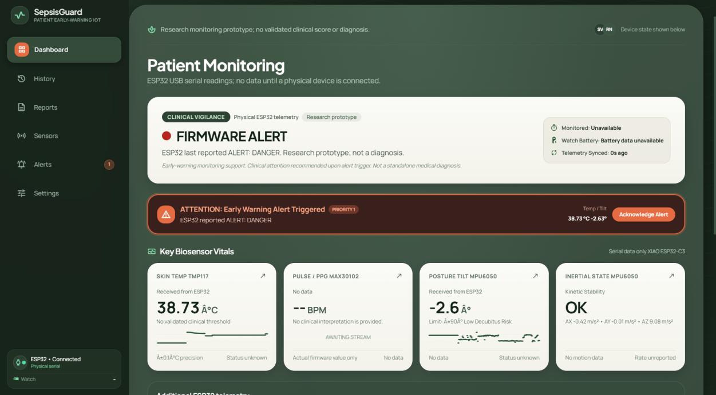

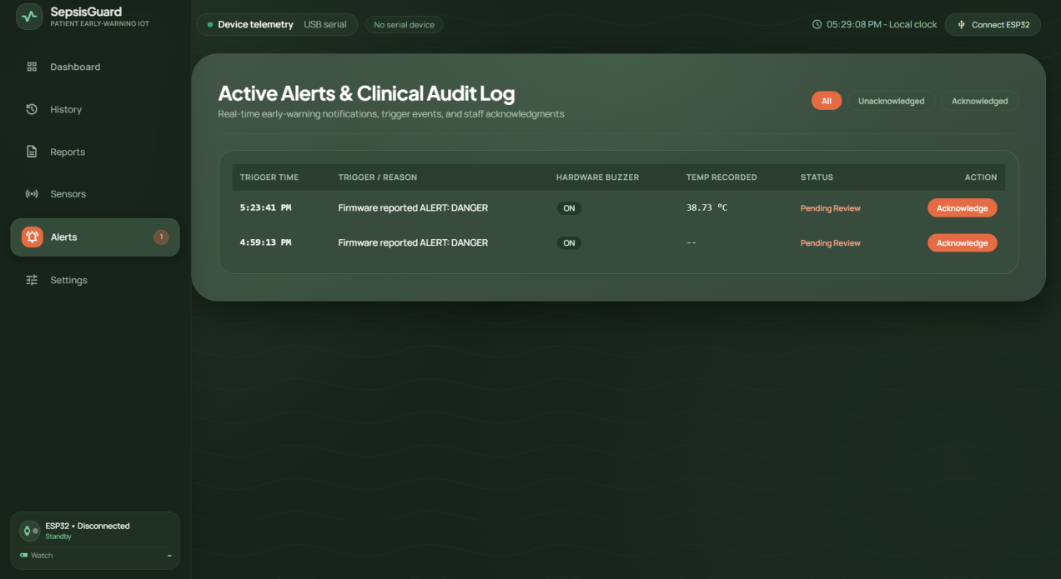

Figure 6.4: Screenshot of the Alerts view of the real dashboard with an active alert
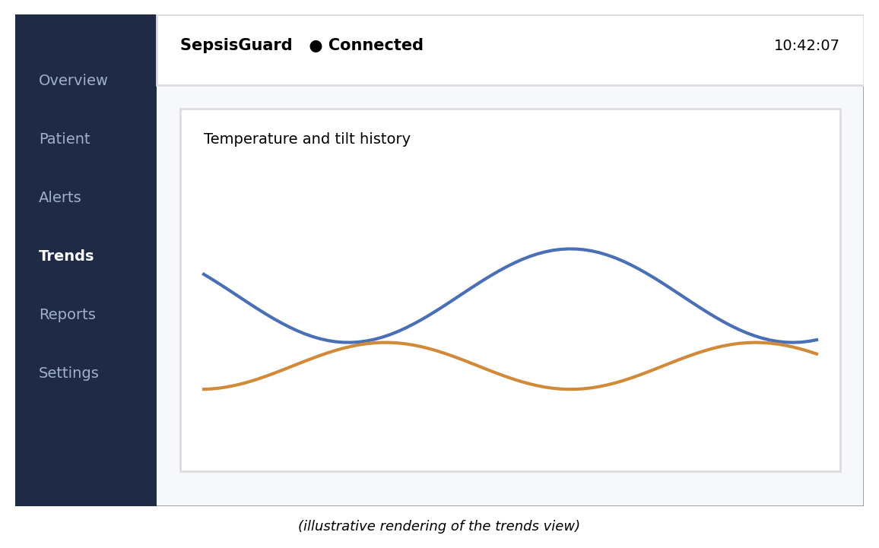
Figure 6.5: Trends view with temperature and tilt history (illustrative rendering)
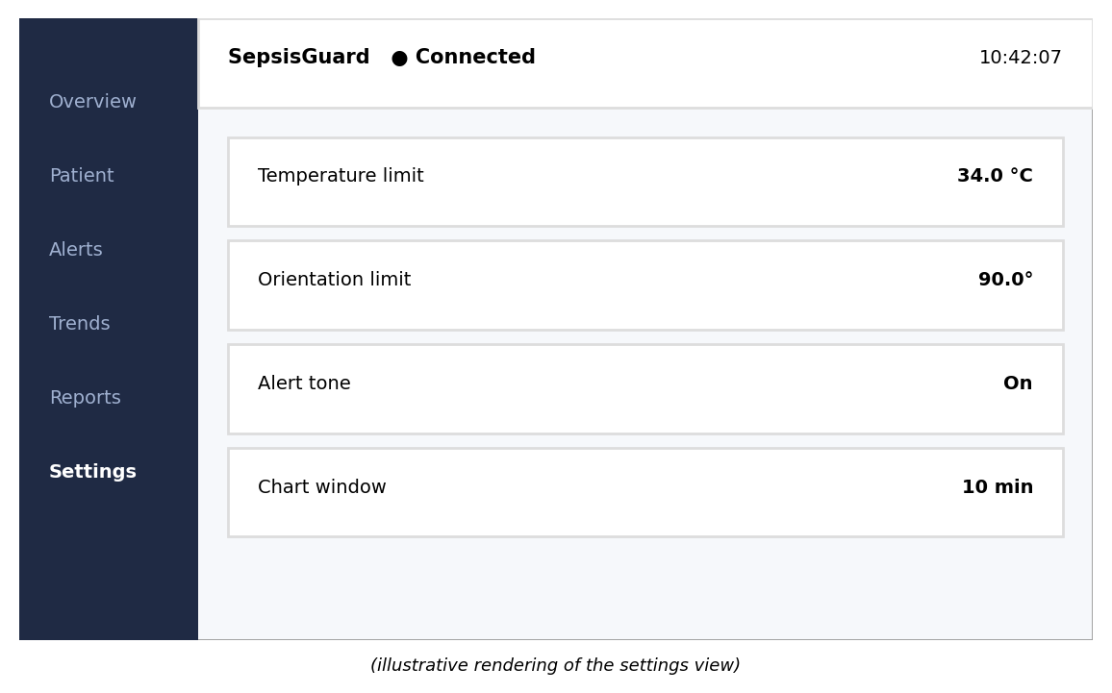
Figure 6.6: Settings view with adjustable limits (illustrative rendering)

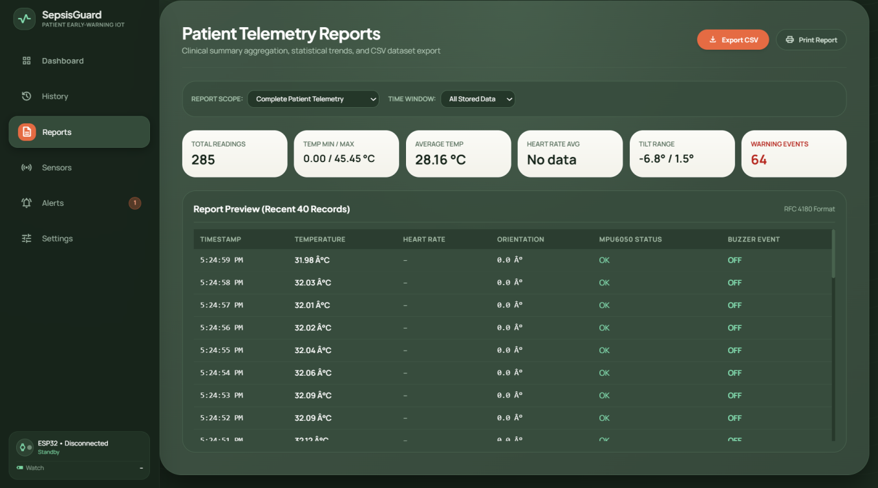
Figure 6.7: Screenshot of the Reports view and an exported file

6.3 Demonstration Scenarios
Five scenarios show how the system behaves. They are designed to be repeated by anyone with the prototype, and each can be checked on the watch and on the dashboard at the same time. The values shown in the illustrative figures are examples and the real values are those displayed in the screenshots inserted above.

6.3.1 Scenario 1: normal state
With the watch on the wrist and the temperature below the limit, the OLED shows the temperature with a normal status, the buzzer is silent, and the dashboard cards show the live values with a green status. The temperature chart scrolls with small variations.

6.3.2 Scenario 2: heart-rate sensor absent
In the demonstration configuration without a MAX30102, the diagnostics screen shows the sensor as not detected, the heart-rate screen shows that no finger is detected, and the dashboard heart-rate card shows disconnected. The temperature and orientation paths continue to work. No number is shown for heart rate.

6.3.3 Scenario 3: temperature above the limit
When the TMP117 is warmed above 34.0 °C, for example by holding the sensor between the fingers in a cool room, the firmware enters the warning state. The buzzer sounds, the OLED shows a warning, and within a moment the dashboard raises the red banner, plays the tone and adds an alert to the ledger that names the temperature and its value.

6.3.4 Scenario 4: orientation beyond 90 degrees
When the forearm is tilted beyond 90° and held there, the same warning sequence follows with the orientation as the triggering parameter. Returning the arm inside the limit clears the state.

6.3.5 Scenario 5: acknowledgement and recovery
A nurse presses acknowledge on the dashboard. The ledger records the acknowledgement time. When the readings return inside the limits, the buzzer stops, the OLED returns to its normal screens, the banner closes and the ledger marks the alert as cleared. The complete record of the episode, with the time of the alert, the acknowledgement and the clearing, remains in the ledger and in the export.
Table 6.2: Demonstration Scenarios and Expected Behaviour
Scenario | Watch | Dashboard
1. Normal | Normal screen, buzzer off | Green cards, scrolling chart
2. No heart-rate sensor | Heart rate: no finger detected | Heart rate shown as disconnected
3. Temperature above limit | Buzzer on, OLED warning | Red banner, tone, ledger entry
4. Orientation beyond limit | Buzzer on, OLED warning | Red banner, tone, ledger entry
5. Acknowledge and recover | Buzzer off, normal screens | Acknowledged then cleared in ledger

6.4 The Mobile Gateway (Phase 2 – Future Build)
The mobile gateway application has not been built in the current phase, so no screens of it are shown in this report; it is planned as a future build for Phase 2. In the planned design, the nurse will open the application, which will scan for the SepsisGuard-Node advertisement and list the watch with its signal strength. After pairing, the nurse will enter the patient details and the application will bind the watch to the patient. The live view will then show temperature, heart rate, orientation, battery level and sensor flags. When the watch enters the warning state, the phone will raise a high-priority notification that names the triggering parameter and offers an acknowledge button. Screenshots of the application will be added once it has been developed and tested in Phase 2.

6.5 How to Run the System
- Fit the sensors and the OLED to the XIAO ESP32-C3 as in Figure 3.3 and upload the firmware.
- Open the serial monitor once to check that the diagnostics screen shows the fitted sensors online.
- Start the dashboard server with Node.js from the dashboard folder and open the address shown in Chrome or Edge.
- Press connect, choose the watch serial port and confirm that the header shows the connected state.
- Run the five scenarios of Section 6.3 and compare the results with Table 6.2.

6.6 Troubleshooting Guide
Table 6.3 lists the problems most likely to be met when running the system and the checks that resolve them.

Table 6.3: Troubleshooting Guide
Symptom | Likely cause | Action
Dashboard cannot find the watch | Charge-only USB cable, wrong browser or port already in use | Use a data cable, open the page in Chrome or Edge, close the serial monitor and any other program using the port
Connect button does nothing | Page opened from a file or an insecure address | Open the page from the local server address
Cards show no values | Watch not printing, wrong baud rate or damaged cycles | Check the serial monitor and the baud rate in the firmware and dashboard
Heart rate shows disconnected | MAX30102 not fitted or no skin contact | Check the diagnostics screen; fit the sensor and press it gently against the skin
OLED stays blank | Wrong address or wiring on D4 and D5 | Check that the display answers on 0x3C and that SDA and SCL are not swapped
Buzzer never sounds | Buzzer connected to the wrong pin | Connect it to D8 (GPIO8); GPIO25 is not used on this board
Buzzer sounds constantly | Limit set too low or sensor reading offset | Check the reading against a reference and the limits in the settings
No tone in the browser | The page has not yet received a user action | Click once on the page; browsers block audio until the user interacts

6.7 Summary
This chapter showed the six dashboard views, five demonstration scenarios, outlined the planned use of the mobile gateway (a Phase 2 future build) and explained how to run the system. The scenarios show how the system behaves and are not accuracy measurements; the tests of Chapter 5 remain the measure of its performance. The next chapter concludes the report.
CHAPTER 7

CONCLUSION AND FUTURE WORK

7.1 Conclusion
This project set out to give a general ward a low-cost way to watch a patient continuously and to warn immediately when the measurements leave agreed limits, without depending on a network. We built a wearable node around the XIAO ESP32-C3 with a TMP117 temperature sensor, a MAX30102 pulse sensor, an MPU6050 motion sensor, an SSD1306 display, a buzzer and a button. The node evaluates the early-warning rule on the device, so the local alarm does not depend on the phone, the server or the browser.
The same readings travel as text over USB serial to a browser dashboard that needs no backend, and the same text is designed to travel, in Phase 2, over Bluetooth Low Energy to an Android gateway, a future build that will bind the watch to a patient, buffer data offline and forward it to a hospital server. The dashboard provides live cards, charts, an alert banner with a tone, an alert ledger with acknowledgement, adjustable limits, reports and export. The central design decision, a transport-independent text protocol, allowed each part to be built and tested separately and allows the transport to change without changing the dashboard.
The project is also candid about its limits. The temperature limit is a demonstration setpoint and not a clinical fever threshold, the sensors are not clinical-grade, the system has not been tested on patients, and it does not diagnose sepsis. It is a decision-support prototype that shows a workable architecture for a low-cost bedside early-warning wearable.

7.2 Limitations
- The warning rule uses two parameters and fixed setpoints. It is a demonstration rule and not a validated clinical score.
- Skin-surface temperature is not core body temperature, and the 34.0 °C limit is not a fever threshold.
- The prototype does not measure respiratory rate, blood pressure or oxygen saturation, which clinical scores need.
- In the demonstration configuration the MAX30102 is not fitted, so heart rate does not take part in the alert.
- Optical heart-rate sensing is sensitive to motion and contact, and the prototype has not been characterised against a clinical reference.
- All tests were bench tests on the team. There was no patient testing, no ethics approval and no regulatory assessment.
- The Web Serial dashboard works only in Chromium-based browsers and needs a cable to the host.
- The mobile gateway application has not been built; it is planned for Phase 2, so at present the watch reaches the dashboard only over a USB cable.
- Battery endurance, enclosure comfort and skin-contact hygiene have not been engineered for clinical use.

7.3 Future Scope
- Phase 2: develop and test the Android mobile gateway application (BLE connection, patient binding, offline buffer and alert acknowledgement) as designed in Chapters 3 and 4, and add its screenshots to the report.
- Replace the demonstration rule with a validated early-warning score such as NEWS2 [7], adding the sensors it needs.
- Fit and characterise the MAX30102 against a reference pulse oximeter and let heart rate take part in the alert.
- Complete the hospital server with authentication, role-based access, patient management, device registry and long-term storage as designed in Chapter 3.
- Add secure pairing, encrypted transport and an audit of every acknowledgement to protect patient data.
- Design a compact printed circuit board and a skin-safe enclosure to reduce size and improve comfort and battery life.
- Add personalised baselines and alert limits per patient to reduce false alarms [15].
- Carry out an ethics-approved, supervised pilot to measure sensitivity, specificity and alert burden against nurse observation.
- Add an automated test suite for the parser, the state store and the firmware logic.

7.4 Summary
This chapter concluded that a wearable node that decides locally and streams the same data to a dashboard is a workable and inexpensive architecture for early warning in a general ward, listed the limitations of the current prototype and outlined future work: the Phase 2 mobile gateway, clinical scores, further sensors, a complete backend, security, hardware design and a supervised pilot.
CHAPTER 8

REFERENCES
[1] L. Singer et al., “The Third International Consensus Definitions for Sepsis and Septic Shock (Sepsis-3),” JAMA, vol. 315, no. 8, pp. 801–810, 2016.
[2] K. E. Rudd et al., “Global, regional, and national sepsis incidence and mortality, 1990–2017: analysis for the Global Burden of Disease Study,” The Lancet, vol. 395, no. 10219, pp. 200–211, 2020.
[3] L. Evans et al., “Surviving Sepsis Campaign: International guidelines for management of sepsis and septic shock 2021,” Intensive Care Med., vol. 47, pp. 1181–1247, 2021.
[4] C. W. Seymour et al., “Assessment of clinical criteria for sepsis: For the Third International Consensus Definitions for Sepsis and Septic Shock (Sepsis-3),” JAMA, vol. 315, no. 8, pp. 762–774, 2016.
[5] A. Kumar et al., “Duration of hypotension before initiation of effective antimicrobial therapy is the critical determinant of survival in human septic shock,” Crit. Care Med., vol. 34, no. 6, pp. 1589–1596, 2006.
[6] S. P. Desautels et al., “Prediction of sepsis in the intensive care unit with minimal electronic health record data: A machine learning approach,” JMIR Med. Inform., vol. 4, no. 3, e28, 2016.
[7] Royal College of Physicians, National Early Warning Score (NEWS) 2: Standardising the assessment of acute-illness severity in the NHS. London, U.K.: RCP, 2017.
[8] M. M. Churpek et al., “Multicenter comparison of machine learning methods and conventional regression for predicting clinical deterioration on the wards,” Crit. Care Med., vol. 44, no. 2, pp. 368–374, 2016.
[9] K. E. Henry, D. N. Hager, P. J. Pronovost, and S. Saria, “A targeted real-time early warning score (TREWScore) for septic shock,” Sci. Transl. Med., vol. 7, no. 299, 299ra122, 2015.
[10] A. E. W. Johnson et al., “MIMIC-III, a freely accessible critical care database,” Sci. Data, vol. 3, 160035, 2016.
[11] World Health Organization, “Sepsis,” fact sheet. [Online]. Available: https://www.who.int/news-room/fact-sheets/detail/sepsis
[12] M. A. Reyna et al., “Early prediction of sepsis from clinical data: The PhysioNet/Computing in Cardiology Challenge 2019,” Crit. Care Med., vol. 48, no. 2, pp. 210–217, 2020.
[13] J. Allen, “Photoplethysmography and its application in clinical physiological measurement,” Physiol. Meas., vol. 28, no. 3, pp. R1–R39, 2007.
[14] C. W. Seymour et al., “Time to treatment and mortality during mandated emergency care for sepsis,” N. Engl. J. Med., vol. 376, pp. 2235–2244, 2017.
[15] S. Sendelbach and M. Funk, “Alarm fatigue: A patient safety concern,” AACN Adv. Crit. Care, vol. 24, no. 4, pp. 378–386, 2013.
[16] Texas Instruments, “TMP117 high-accuracy, low-power, digital temperature sensor with SMBus- and I2C-compatible interface,” datasheet.
[17] Maxim Integrated (Analog Devices), “MAX30102 high-sensitivity pulse oximeter and heart-rate sensor for wearable health,” datasheet.
[18] InvenSense, “MPU-6000 and MPU-6050 product specification,” datasheet.
[19] NXP Semiconductors, “UM10204: I2C-bus specification and user manual.”
[20] Espressif Systems, “ESP32-C3 series datasheet.”
[21] Seeed Studio, “Getting started with Seeed Studio XIAO ESP32-C3,” product wiki.
[22] Solomon Systech, “SSD1306 128 × 64 dot matrix OLED/PLED segment/common driver with controller,” datasheet.
[23] Bluetooth SIG, “Bluetooth Core Specification,” Generic Attribute Profile (GATT).
[24] W3C Web Platform Incubator Community Group, “Web Serial API,” specification. [Online]. Available: https://wicg.github.io/serial/
[25] W3C, “Web Audio API,” specification. [Online]. Available: https://www.w3.org/TR/webaudio/
CHAPTER 9

APPENDIX

9.1 Pin and Address Quick Reference
Table 9.1: Pin and I2C Quick Reference
Item | Value
I2C SDA / SCL | D4 (GPIO6) / D5 (GPIO7), 3.3 V
Buzzer | D8 (GPIO8), active buzzer
Button | D3 (GPIO5), pull-up, active LOW
TMP117 | I2C 0x48 (ADD0 to GND)
MAX30102 | I2C 0x57
MPU6050 | I2C 0x68 (AD0 to GND)
SSD1306 | I2C 0x3C
Warning rule | T > 34.0 °C OR |θ| > 90.0° (strict)

9.2 Project Directory Structure
Sepsis-Guard/
firmware/ Arduino sketch for the XIAO ESP32-C3
dashboard/ index.html, JavaScript modules, Node.js static server
android/ Android gateway application (Phase 2, planned)
docs/ documentation and report

9.3 Main Commands
# Serve the dashboard (Node.js v14 or later, no dependencies)
node server.js

# Open in Chrome or Edge, press Connect, choose the watch serial port
# http://localhost:<port>

9.4 Bench Test Record Sheet
Table 9.2: Bench Test Record Sheet (template)
Date | Test | Setpoint | Observed | Pass / fail | Initials

9.5 Glossary of Terms
Table 9.3: Glossary
Term | Meaning
Alert ledger | The record of every alert with its time, triggering parameter, acknowledgement and clearing time
Strict comparison | A comparison that does not include the limit itself (greater than, not greater than or equal)
Telemetry cycle | One complete set of readings printed or sent by the watch
Demonstration setpoint | A limit chosen for laboratory work that is not a clinical threshold
Gateway | The phone application, planned for Phase 2, that will relay, identify and buffer the stream
Edge decision | A decision taken on the device itself, without a network

9.6 Safety and Ethics Statement
SepsisGuard is an educational prototype. It has not been tested on patients, has no regulatory approval and must not be used to diagnose, monitor or treat any patient. All tests described in this report were carried out on the project team under laboratory conditions with their informed agreement. Any clinical use would require ethics approval, risk analysis, regulatory clearance and supervision by qualified clinicians.
CHAPTER 10

SOURCE CODE

10.1 Overview of the Source Code
The complete source code of SepsisGuard is available at https://github.com/Vishal-VK18/Sepsis-Guard. The ward dashboard (web monitor) consists of a Node.js static server (server.js), a single HTML page with its stylesheet, and six JavaScript modules under js/. This chapter lists the key functions of each stage: the static server, the telemetry parser, the Web Serial manager with its offline simulator, the state store and alert ledger, the trend charts, the report export and the application controller. The remaining functions follow the same structure and are part of the project files.

10.2 Static Web Server (server.js)
A dependency-free Node.js server delivers the dashboard files on port 3000 and maps each file extension to its MIME type.
const http = require('http');
const fs = require('fs');
const path = require('path');

const PORT = 3000;
const ROOT = __dirname;

const MIME = {
'.html': 'text/html',
'.css': 'text/css',
'.js': 'application/javascript',
'.json': 'application/json',
'.png': 'image/png',
'.jpg': 'image/jpeg',
'.svg': 'image/svg+xml',
};

const server = http.createServer((req, res) => {
let reqPath = req.url.split('?')[0];
if (reqPath === '/' || reqPath === '') reqPath = '/index.html';

const filePath = path.join(ROOT, reqPath);
const ext = path.extname(filePath).toLowerCase();
const contentType = MIME[ext] || 'application/octet-stream';

fs.readFile(filePath, (err, content) => {
if (err) {
if (err.code === 'ENOENT') {
res.writeHead(404, { 'Content-Type': 'text/plain' });
res.end('404 Not Found');
} else {
res.writeHead(500);
res.end('Server Error: ' + err.code);
}
} else {
res.writeHead(200, { 'Content-Type': contentType });
res.end(content);
}
});
});

server.listen(PORT, '127.0.0.1', () => {
console.log(`SepsisGuard server running at http://127.0.0.1:${PORT}/`);
});

10.3 Telemetry Parser (js/parser.js)
The parser collects the text printed by the watch, recognises each field with a regular expression and emits one reading when a telemetry cycle is complete.
export class ESP32Parser {
// ...
feed(chunk) {
this.buffer += chunk;
const lines = this.buffer.split('\n');
this.buffer = lines.pop();

for (const rawLine of lines) {
const line = rawLine.replace(/\r$/, '').trim();
if (line.length > 0) {
this.parseLine(line);
}
}
}
// ...
parseLine(line) {
this.onRawLine(line);

// End-of-cycle delimiter (standard delimiter convention)
if (line.startsWith('=====')) {
if (this.hasActiveFields) {
this.emitCycle();
}
return;
}

// Auto-emit if a new cycle starts without explicit ===== delimiter
if (line.match(/^Temperature:/i) && this.currentCycle.temperature !== null) {
this.emitCycle();
}

// TMP117 Temperature Parsing
// e.g. "Temperature: 34.20 C", "Temperature: 34.2 C"
const tempMatch = line.match(/^Temperature:\s*([0-9.]+)\s*C?/i) || line.match(/^(?:TMP117|Temp):\s*([0-9.]+)/i);
if (tempMatch) {
this.currentCycle.temperature = parseFloat(tempMatch[1]);
this.currentCycle.tmp117Error = false;
this.hasActiveFields = true;
return;
}
// ...
if (line.includes('MAX30102: NO FINGER')) {
this.currentCycle.heartRate = null;
this.currentCycle.max30102Connected = true;
this.currentCycle.max30102Status = 'NO_FINGER';
this.hasActiveFields = true;
return;
}
// ...
// Buzzer State Parsing - CRITICAL ALERT SOURCE OF TRUTH
// "BUZZER: ON - HIGH TEMPERATURE"
if (line.includes('BUZZER: ON - HIGH TEMPERATURE')) {
this.currentCycle.buzzerState = 'ON';
this.currentCycle.buzzerReason = 'High Temperature';
this.hasActiveFields = true;
return;
}
// ...
emitCycle() {
this.currentCycle.timestamp = new Date();
this.onReadingComplete({ ...this.currentCycle });
this.currentCycle = this.createEmptyCycle();
this.hasActiveFields = false;
}

10.5 State Store and Alert Ledger (js/state.js)
The state module applies the warning rule to every reading, opens one alert for each episode, records it in the alert ledger and supports acknowledgement.
const STORAGE_KEY_HISTORY = 'sepsisguard_telemetry_history_v1';
const STORAGE_KEY_ALERTS = 'sepsisguard_alerts_history_v1';
const STORAGE_KEY_SETTINGS = 'sepsisguard_settings_v1';
const MAX_HISTORY_POINTS = 1000;
// ...
export function recordReading(reading) {
const timestamp = new Date();
// ...
// Alert Condition Check:
// 1. Hardware Buzzer explicitly ON via ESP32 output
// 2. Temperature > 34.0 °C
// 3. Absolute orientation angle > 90°
const isHighTemp = typeof state.current.temperature === 'number' && state.current.temperature > state.settings.tempThreshold;
const isAbnormalOrientation = typeof state.current.orientation === 'number' && Math.abs(state.current.orientation) > state.settings.orientationThreshold;
const isExplicitBuzzerOn = reading.buzzerState === 'ON';
const isBuzzerActive = isExplicitBuzzerOn || isHighTemp || isAbnormalOrientation;

state.current.buzzer.state = isBuzzerActive ? 'ACTIVE' : 'OFF';

let alertReason = '';
if (isHighTemp && isAbnormalOrientation) {
alertReason = 'Elevated Temperature & Posture Change';
} else if (isHighTemp) {
alertReason = 'Elevated Temperature (> 34.0 °C)';
} else if (isAbnormalOrientation) {
alertReason = 'Abnormal Orientation / Posture (> 90°)';
} else if (isExplicitBuzzerOn) {
alertReason = reading.buzzerReason || 'Patient Early Warning';
}

state.current.buzzer.reason = isBuzzerActive ? alertReason : '';

if (isBuzzerActive) {
if (!state.activeAlert) {
state.activeAlert = {
id: 'alert-' + timestamp.getTime(),
timestamp: timestamp.toISOString(),
displayTime: timestamp.toLocaleTimeString([], { hour: '2-digit', minute: '2-digit' }),
temperature: state.current.temperature,
orientation: state.current.orientation,
heartRate: state.current.heartRate,
reason: alertReason,
threshold: state.settings.tempThreshold,
acknowledged: false,
ackTime: null,
};

state.alertsHistory.unshift({
id: state.activeAlert.id,
timestamp: timestamp.toISOString(),
displayTime: timestamp.toLocaleTimeString([], { hour: '2-digit', minute: '2-digit' }),
event: `Patient Alert: ${alertReason} (${state.current.temperature !== null ? state.current.temperature.toFixed(1) + ' °C' : ''})`,
hardwareBuzzer: 'ACTIVE',
acknowledged: false,
ackTime: null,
audit: 'Unacknowledged',
temperature: state.current.temperature,
orientation: state.current.orientation,
heartRate: state.current.heartRate,
});

notify('alert_triggered', state.activeAlert);
}
} else {
// Alert condition resolved
if (state.activeAlert) {
const clearedAlert = state.activeAlert;
state.activeAlert = null;
notify('alert_cleared', clearedAlert);
}
}
// ...
export function acknowledgeAlert(alertId, operator = 'Clinical Staff') {
const now = new Date();
let found = false;

if (state.activeAlert && (state.activeAlert.id === alertId || !alertId)) {
state.activeAlert.acknowledged = true;
state.activeAlert.ackTime = now.toISOString();
found = true;
}

state.alertsHistory = state.alertsHistory.map(a => {
if (a.id === alertId || (!alertId && !a.acknowledged)) {
found = true;
return {
...a,
acknowledged: true,
ackTime: now.toISOString(),
audit: operator,
};
}
return a;
});

saveState();
notify('alert_acknowledged', { alertId, operator, ackTime: now });
return found;
}

10.8 Application Controller and Alert Tone (js/app.js)
The controller connects the parser, the serial manager and the state store, synthesises the alert tone and redraws the views when the state changes.
function playAlertTone() {
if (isAudioMuted) return;
try {
if (!audioCtx) {
audioCtx = new (window.AudioContext || window.webkitAudioContext)();
}
if (audioCtx.state === 'suspended') {
audioCtx.resume();
}
const osc = audioCtx.createOscillator();
const gain = audioCtx.createGain();
osc.type = 'sine';
osc.frequency.setValueAtTime(880, audioCtx.currentTime); // A5
osc.frequency.setValueAtTime(1174.66, audioCtx.currentTime + 0.1); // D6
gain.gain.setValueAtTime(0.12, audioCtx.currentTime);
gain.gain.exponentialRampToValueAtTime(0.01, audioCtx.currentTime + 0.3);
osc.connect(gain);
gain.connect(audioCtx.destination);
osc.start();
osc.stop(audioCtx.currentTime + 0.3);
} catch (e) {
console.warn('Audio play failed:', e);
}
}
// ...
document.addEventListener('DOMContentLoaded', () => {
initStore();

// Serial Parser Setup
const parser = new ESP32Parser(
(reading) => {
recordReading(reading);
},
(rawLine) => {
appendTerminalLine(rawLine);
}
);

// Serial Manager Setup
const serialManager = new SerialManager(parser, {
onConnect: (info) => {
updateConnectionUI(true, info);
},
onDisconnect: () => {
updateConnectionUI(false);
},
onError: (err) => {
console.error('Serial Error:', err);
appendTerminalLine(`[ERROR: ${err.message || err}]`, true);
},
onStatusChange: (status) => {
updateStatusBadge(status);
},
// ...
// Initial UI Render
renderDashboard(state);
renderSparklines();
renderTimeline(state.alertsHistory);

// Live Clock
setInterval(updateLiveClock, 1000);
updateLiveClock();
});
// ...
function handleStateUpdate(event, payload, currentState) {
renderDashboard(currentState);

if (event === 'reading_recorded') {
renderSparklines();
} else if (event === 'alert_triggered' || event === 'alert_acknowledged' || event === 'alert_cleared') {
renderTimeline(currentState.alertsHistory);
}
}

